“Mobile Store Management System”

A Minor Project Report
Submitted in partial fulfilment of the requirements for the
Award of degree of Bachelor of Computers Application
(BCA)

2020-2023

Submitted By:
Sarthak Oberoi (0201BCA046)

Guided By:
Mr. Mahesh Kumar Chaubey





BHARATI VIDYAPEETH
(DEEMED TO BE UNIVERSITY)
INSTITUTE OF MANAGEMENT & RESEARCH, NEW DELHI
A-4, Paschim Vihar, New Rohtak Road, New Delhi-110063
STUDENT UNDERTAKING

This is to certify that the project titled “Mobile Store Management System” submitted to “Bharati Vidyapeeth (Deemed to be University), Pune” in partial fulfilment of the requirement for the award of the degree of “Bachelor of Computer Applications” is an original work carried out under the guidance of Mr Mahesh Kumar Chaubey. The matter embodied in this project is a genuine work done by me and has been submitted neither to this University nor to any other University for the fulfilment of the requirement of the course of study.

Sarthak Oberoi
ERPID: 0201BCA046
PRN: 2020100260

CERTIFICATE FROM INTERNAL GUIDE

This is to certify that the Project titled “Mobile Store Management System” is an academic work done by Sarthak Oberoi submitted in the partial fulfilment of the requirement for the award of the Degree of “Bachelor of Computer Applications” from “Bharati Vidyapeeth (Deemed to be University), Pune” under my guidance & direction.

To the best of my knowledge and belief the data & information presented by him in the project has not been submitted earlier whether to this University or to any other University / Institute for the fulfilment of the requirement of any course of study.

Mr. Mahesh Kumar Chaubey
(Internal Guide)

CERTIFICATE FROM THE DIRECTOR

This is to certify that the Project titled “Mobile Store Management System” is an academic work done by Sarthak Oberoi submitted in partial fulfilment of the requirement for the award of the Degree of Bachelor of Computer Applications from Bharati Vidyapeeth (Deemed to be University), Pune.

The authenticity of the project work will be examined by the viva examiner which includes data verification, checking duplicity of information etc. and it may be rejected due to non-fulfilment of quality standards set by the institute.

Signature
Dr. Yamini Agarwal
Director

ACKNOWLEDGEMENT

I would like to express our gratitude and appreciation to all those who gave me the possibility to complete this report. A special thanks to my Minor project Guide Mr. Mahesh Kumar Chaubey whose help, stimulating suggestions and encouragement, helped me to coordinate my project especially in writing this report topic and achieving the goal as well as his encouragement to maintain our progress in track. I would appreciate the guidance given by other supervisors as well as the panels especially in our project presentation that has improved my presentation skills by their comment and tips.

CONTENT

 | CHAPTERS | Page No.
1 | INTRODUCTION | 1
1.1 | Introduction about Project | 1
1.2 | Need of Computerization of System/ Problem in existing system | 2
1.3 | Proposed Software | 3
1.4 | Importance of the Work/project | 4
2 | SYSTEM ANALYSIS | 6
2.1 | Analysis Methodology /requirement gathering techniques | 6
2.2 | Feasibility Study | 6
2.3 | Choice of Platforms | 8
2.3.1 | Software used | 8
2.3.2 | Hardware used | 8
 | SYSTEM DESIGN | 9
3.1 | Process Model used | 9
3.2 | Database Design (ERD/Data Dictionary/ Table Design) | 11
3.3 | Functional Design (DFD) | 12
3.4 | Interface Design (Screenshots of forms) | 14
3.5 | Output Design (Screenshots of Report) | 18
4 | TESTING AND IMPLEMENTATION | 22
4.1 | Testing Methodology | 22
4.2 | Testing Methodology applied | 23
4.3 | Test Cases | 24
4.4 | Test Data | 28
4.5 | Gap Analysis | 28
4.6 | Rework/ Retest | 28
4.7 | Hardware & Software Requirement | 29
4.7.1 | Hardware Requirement
4.7.2 | Software Requirement
5 | CONCLUSION AND REFERENCES | 30
5.1 | Conclusion | 30
5.2 | Limitation of System | 31
5.3 | Future Scope for Modification | 31
5.4 | References/ Bibliography | 32
6 | ANNEXURES | 33
6.1 | Menu Flow Diagram | 33
6.2 | Sample Input | 34
6.3 | Sample Output | 37
6.4 | Program Code | 40
6.5 | Mentor Feedback Report | 60

CHAPTER 1
INTRODUCTION

1.1 INTRODUCTION ABOUT THE PROJECT

The Mobile Store Management System was created specifically for the purpose of entering records for mobile phones in mobile showrooms.
The user can conveniently save mobile records according to their brands (Samsung, Nokia, Sony, LG, Apple, etc.) in this system. At any time, the user can add, update, view, or delete a mobile’s record. Records are organised in a logical manner, with their availability status, quantity, and prices indicated.

Following are few characteristics of our system:
- User-Friendly prompts are provided for user.
- Attractive interfaces used for user interaction
- Strong management system controls are used easy Navigation is provided for maintaining proper flow of system.

It aims at developing a software that can be easily used to manually do the tasks of Add, Delete, Search and Edit inventory records. The main merit of this project is that it converts all manual work which is time taken and error taken to fully automatic system which helps in eliminating all the paper work, saves time, thus providing convenience to the Inventory Manager.

The project starts with login page, followed by the home page. Gym management software or fitness software is a software solution that helps businesses to streamline, organize, and run their operations. While you can have a big range of functionality, the majority of Inventory management systems offer both an employee and a client-facing portal. The platform allows shop owners to better manage their products.

1.2 EXISTING SYSTEM

Existing system is a manual system, when the user wants to add or update a new mobile to the inventory, he has to do this via physical medium i.e., notebook.

All the work is done manually in the existing system, so it takes more time by the managers. Another disadvantage of the existing system is that search, delete, add, edit done manually is difficult and time consuming. This will take more time, currently a one-day process for verifying all records. So, after conducting the feasibility study we decide to make a computerized Mobile Store Management System.

Drawbacks or disadvantages of the existing product:
1. Manual system
2. Time consuming
3. No Desktop Application
4. No Security
5. Prone to Damage and Being Misplaced
6. Takes Up a Lot of Space
7. Manual Attendance

LIMITATIONS OF THE PRESENT SYSTEM
The current system has several shortcomings that are as follows:
- The existing system was not very effective & was highly time consuming.
- The current system works manually.
- The existing system was somewhat paper-based (paper-work) which takes time.
- The rate at which the work done is very slow due to non-utilization of computerized system.
- It does not provide better data facilities as well as data availability on fingertip.
- Inconsistency was the major problem in the existing system as there is no proper facility was provided to update the data.
- In case user wants to find out details of particular Mobiles whole database records are displayed.
- It is difficult to remember all data
- Consumes large volume of paper work
- Large storage space is required to keep to the files and register in proper coordination's
- In the present system the report generation becomes very difficult.

1.3 PROPOSED SYSTEM

There are many reasons to select this system, one of the main reasons is that the existing system is a manual system, also a time-consuming one. There is a need for this type of system which is easy to access as well as manageable to the shopkeepers.

Desktop Applications are very useful and easily manageable by the end user. Such applications help in maintaining large amounts of data and also helpful in updating the data at a faster speed then the manual process. Which requires a physical medium like multiple notebooks to store the inventory data which makes it harder to update.

The information about the various products in the store, the mobile phones of different brands with their price, quantity availability etc. can get by just a few clicks unlike the paper documents required the serious reading for such information.

It will also give a layer of security to the administration and the users that only authorized users can access by their credentials.

In the mobile store management system, after the planning and analysis phase of the system gets completed. Then the next phase required to transform the collected required system information into a structural blueprint which will serve as a reference while constructing the working system. It is a phase when most of the risks and errors unveiled so it’s is good practice to take care of this thing from the start.
This is a fully-fledged system that will be the backbone of the whole management of the inventory so ignoring the risk or error is not an option as later it can make a greater form of itself. So, it is better to minimize the problems faced by both staff and the manager in the Organization.

- This system computerizes all data is storing all data of the Mobiles Sales, Customer Details, Employee Details along with Salary.
- Validation at the time of entering data, so no chance of duplication of data.
- Extensive Validation on input record so that no changeable record is Prone to error.
- Response time for the query should be minimized.
- To keep data base up to date by regular updating.
- Reduce the cost of maintaining system.
- To provide various report facility.
- Cost effective and less manpower required.

1.4 ADVANTAGES/SCOPE OF PROPOSED SYSTEM
- There is a password system in our application, where a user who has the password can access the system.
- There is a file system used for our inventory, because that helps in maintaining the data on the basis of different brands.
- We can add, delete and update the records.
- We can also search the mobile records easily.
- The new system would easily overcome most of the short coming of the current system.
- Owner can see the fine report.

Figure 1: Advantages of the proposed system
CHAPTER 2
SYSTEM ANALYSIS

2.1 ANALYSIS METHODOLOGY/ REQUIREMENT GATHERING TECHNIQUES

Requirement gathering is the process of generating a list of requirements from the various stakeholders that will be used as the basis for the requirements definition.

Requirements gathering are essential for almost every project. The process of reviewing a business’s processes to determine the business needs and functional requirements that a system must meet, explanation of requirements gathering.

2.2 FEASIBILITY STUDY

As we all know that each and every project needs to have a feasibility study for the complete understanding ability of the entire system.
A project feasibility is a comprehensive report that examines in detail about the system. It is an evaluation of a proposed system or project to determine if it.

(1) Is technically feasible,
(2) Is feasible within estimated cost, or
(3) Will be profitable.

A feasibility study is a primary study that understands before the real work of a project starts to certain the project success.

Economic feasibility

The purpose of economic feasibility study is to demonstrate the net benefit of a proposed system for accepting the benefits, taking into consideration the benefits and costs to the agency, other state agencies, and the general public as a whole.

In other words, analysis of a project’s costs and revenues is an effort to determine whether or not it is logical and possible to complete it or not.

As our proposed system is a desktop based mobile store, which is very easy to operate and less complicated than other manual processes. It is beneficial to buy this software as it is cost effective. It can be used or operated by any one easily. Internet connection is not required to access it.

Categorization of mobiles is done here, so that users can access them easily. Also, there is a security of password for accessing the inventory.

Technical feasibility

Technical feasibility is a complete study of the project in terms of input, processes, output, fields, programs and procedures. It is a feasibility that is concerned with specifying equipment and software that will successfully satisfy the user requirements.

It directs the technical needs of the system. The project should be developed such that the necessary functions and performance are being achieved. This project is developed with the latest technology.

Operational feasibility

Operational feasibility is the measure of how a system solves the problem, and takes the advantage of different opportunities identified during scope definition and how it satisfies the requirements in the requirements analysis phase of the system development.

Operational feasibility is the one that can be used successfully after it has been developed.

Our application is easy to implement and practice in the real world. Also, it is very easy to operate after being implemented and we can say that this project is operationally feasible.

2.3 CHOICE OF PLATFORMS
2.3.1 HARDWARE USED

- Processor - Intel core i5 9300-H
- Clock speed - 4.1 GHZ
- System bus - 64 bits
- RAM - 16GB of RAM
- SSD - Samsung 980 500 GB

2.3.2 SOFTWARE USED

- OS - Microsoft Windows 11
- Front End - Net beans IDE
- Back End - MySQL Database
- Language - Java

CHAPTER 3
SYSTEM DESIGN

  - PROCESS MODEL USED

Out of all the process models available for system design, we chose the waterfall model for designing.
We used this type of system design model because it is giving us some major advantages over other models for making this specific system
Some advantages include:

- Simplicity and easily understandable model
- Easily manageable due to rigidity of the model.
- Each phase has specific deliverables and a review process.
- Phases are processed and completed one at a time.
- Works well for smaller projects where requirements are very well understood.
- Clearly defined stages.
- Well understood milestones.
- Easy to arrange tasks.
- Process and results are well documented.

    - WATERFALL MODEL

The waterfall model is a sequential design process, used in software development processes, in which progress is seen as flowing steadily downwards (like a waterfall) through the phases of conception, initiation, analysis, design, construction, testing, production/implementation, and maintenance.
The waterfall model shows the software development process in a linear sequence. This means each phase must be completed before the next phase and also the phases do not overlap. The various are shown below:
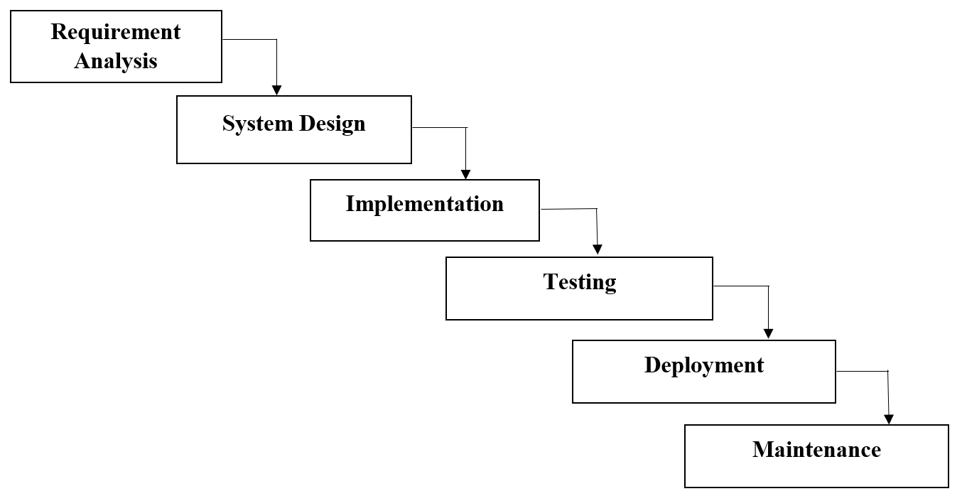

- Requirement analysis – All the possible requirements of the systems are gathered and documented in a requirements specification document. We gather each and every possible requirement of the customer.
- System design – The requirements of the first phase are being studied and then the system is prepared. It helps in specifying the hardware and software requirements and helps in defining the architecture of the system. On the basis or requirements gathered, design of the system/work product is made.
- Implementation – With inputs from the system design, the system is developed in small programs called units which are being integrated. Each unit is developed and tested for functionality performance. With the help of system design, suitable code is generated.
- Testing – The entire system is tested for any kind of faults or failures. Small units of the entire code are tested separately here.
- Deployment – Once the testing is being done, the product is being deployed in the customer environment or released into the market.
- Maintenance – To enhance the product some better versions are released. So for this, maintenance is done to deliver the changes in the customer’s environment.

All these phases are linked to each other in which progress is seen as flowing downwards through the phases. The next phase is started only when the previous phase is being completed.

3.2 DATABASE DESIGN

Tables in Mobile Store Management System
+----------------+
| Tables_in_msms |
+----------------+
| bills |
| category |
| item |
| user |
+----------------+

Table Description: Bills

+-------------+--------------+------+-----+---------+-------+
| Field | Type | Null | Key | Default | Extra |
+-------------+--------------+------+-----+---------+-------+
| billno | int | NO | PRI | NULL | |
| cname | varchar(200) | YES | | NULL | |
| cemail | varchar(200) | YES | | NULL | |
| cmobile | varchar(200) | YES | | NULL | |
| itemid | varchar(100) | YES | | NULL | |
| category | varchar(100) | YES | | NULL | |
| brand | varchar(100) | YES | | NULL | |
| modelnumber | varchar(100) | YES | | NULL | |
| modelname | varchar(100) | YES | | NULL | |
| variant | varchar(100) | YES | | NULL | |
| imei | varchar(100) | YES | UNI | NULL | |
| price | int | YES | | NULL | |
| soldby | varchar(200) | YES | | NULL | |
+-------------+--------------+------+-----+---------+-------+

Table Description: Category

+-------+--------------+------+-----+---------+----------------+
| Field | Type | Null | Key | Default | Extra |
+-------+--------------+------+-----+---------+----------------+
| id | int | NO | PRI | NULL | auto_increment |
| name | varchar(200) | YES | | NULL | |
+-------+--------------+------+-----+---------+----------------+

Table Description: Item

+-------------+--------------+------+-----+---------+----------------+
| Field | Type | Null | Key | Default | Extra |
+-------------+--------------+------+-----+---------+----------------+
| id | int | NO | PRI | NULL | auto_increment |
| category | varchar(100) | YES | | NULL | |
| brand | varchar(100) | YES | | NULL | |
| modelnumber | varchar(100) | YES | | NULL | |
| modelname | varchar(100) | YES | | NULL | |
| variant | varchar(100) | YES | | NULL | |
| imei | varchar(100) | YES | UNI | NULL | |
| price | int | YES | | NULL | |
+-------------+--------------+------+-----+---------+----------------+

Table Description: User

+------------+--------------+------+-----+---------+----------------+
| Field | Type | Null | Key | Default | Extra |
+------------+--------------+------+-----+---------+----------------+
| id | int | NO | PRI | NULL | auto_increment |
| password | varchar(200) | YES | | NULL | |
| firstname | varchar(50) | YES | | NULL | |
| lastname | varchar(50) | YES | | NULL | |
| dob | date | YES | | NULL | |
| address | varchar(500) | YES | | NULL | |
| email | varchar(100) | YES | UNI | NULL | |
| mobile | varchar(15) | YES | | NULL | |
| since | date | YES | | NULL | |
| approved | varchar(5) | YES | | NULL | |
| approvedby | varchar(50) | YES | | NULL | |
+------------+--------------+------+-----+---------+----------------+

3.2.1 ERD

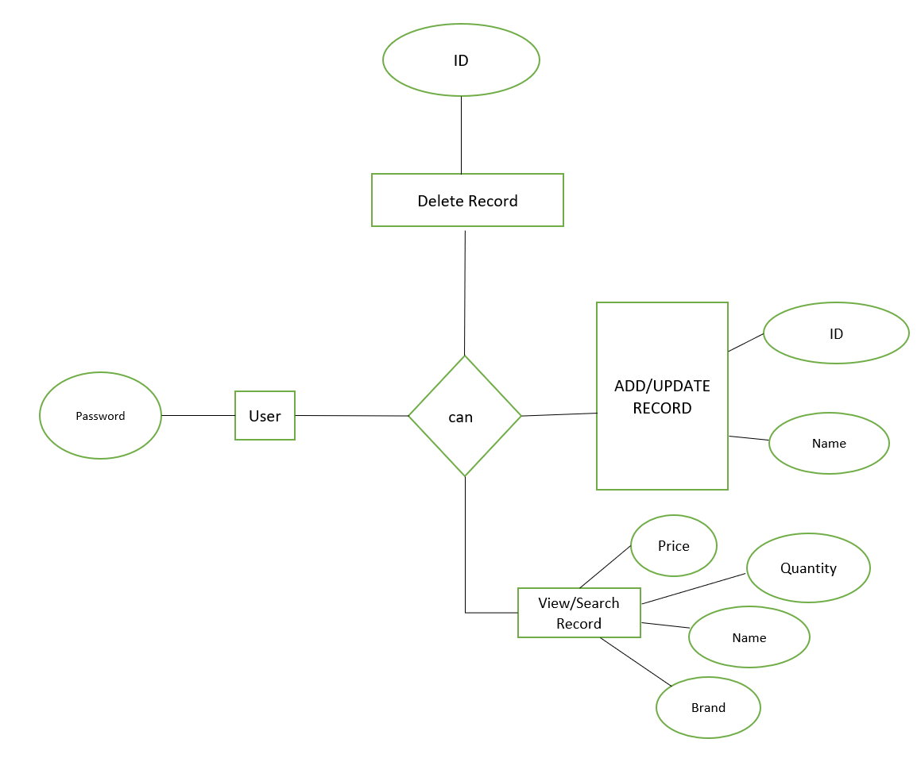

3.3 FUNCTIONAL DESIGN
3.3.1 DFD MODEL

A data flow diagram is a way of representing a flow of data of the system. This model also provides information about the inputs and the outputs of every entity and the processes. This type of diagram has no control flow, and there are no decision rules and loops.
- DFD LEVEL-ZERO
This diagram is a top-level data flow diagram. It only contains one process that generalises the function of entire system in relationship to outside entities

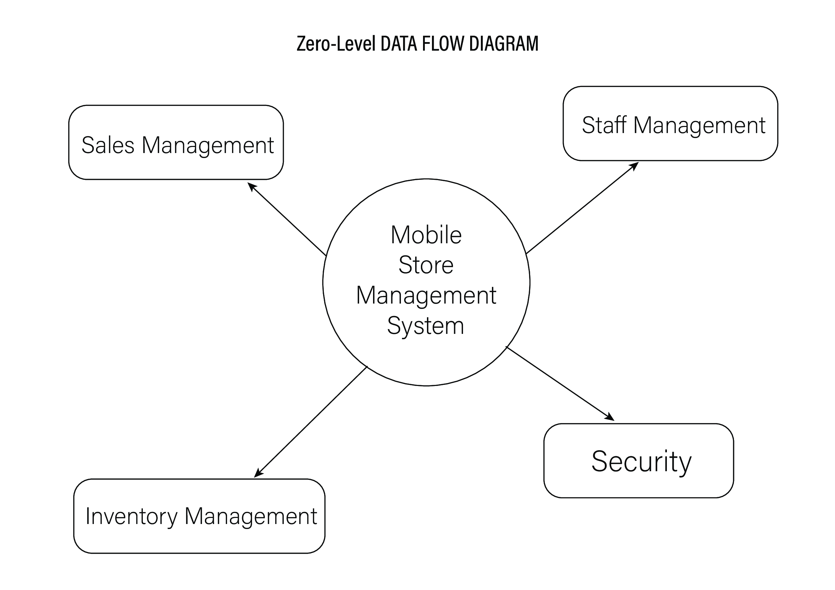

- DFD LEVEL-ONE
A level 1 data flow diagram is more detailed than the 0-level data flow diagram but not as detailed as level 2 data flow diagram. It breaks down the main processes into sub-processes that can then be analysed and improved on a more familiar level.

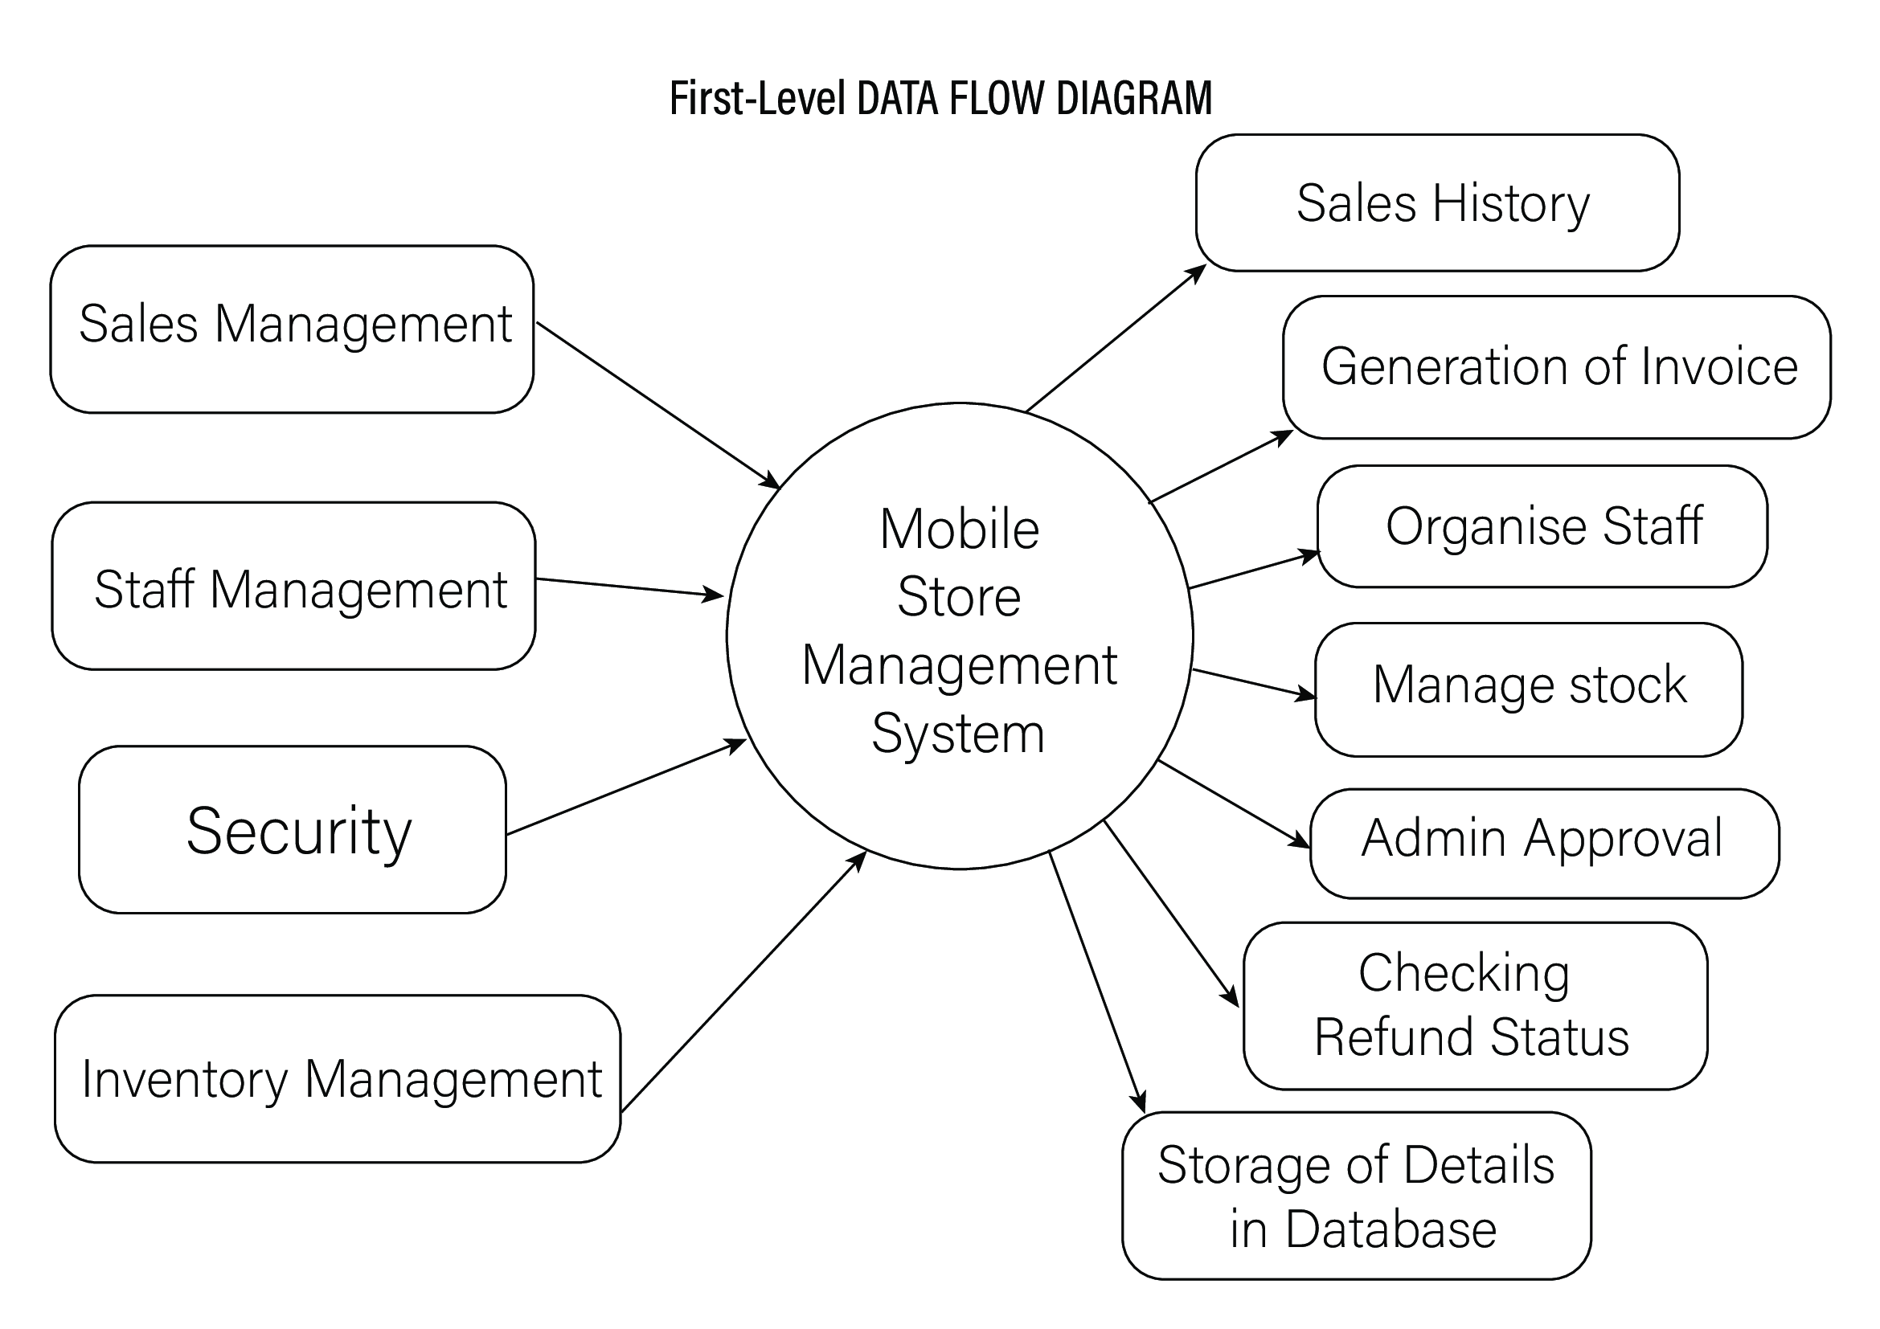

- DFD LEVEL-TWO
In this level, we highlight the main functions of the system and breakdown the high-level process of 0-level DFD into subprocesses. 2-level DFD: 2-level DFD goes one step deeper into parts of 1-level DFD.

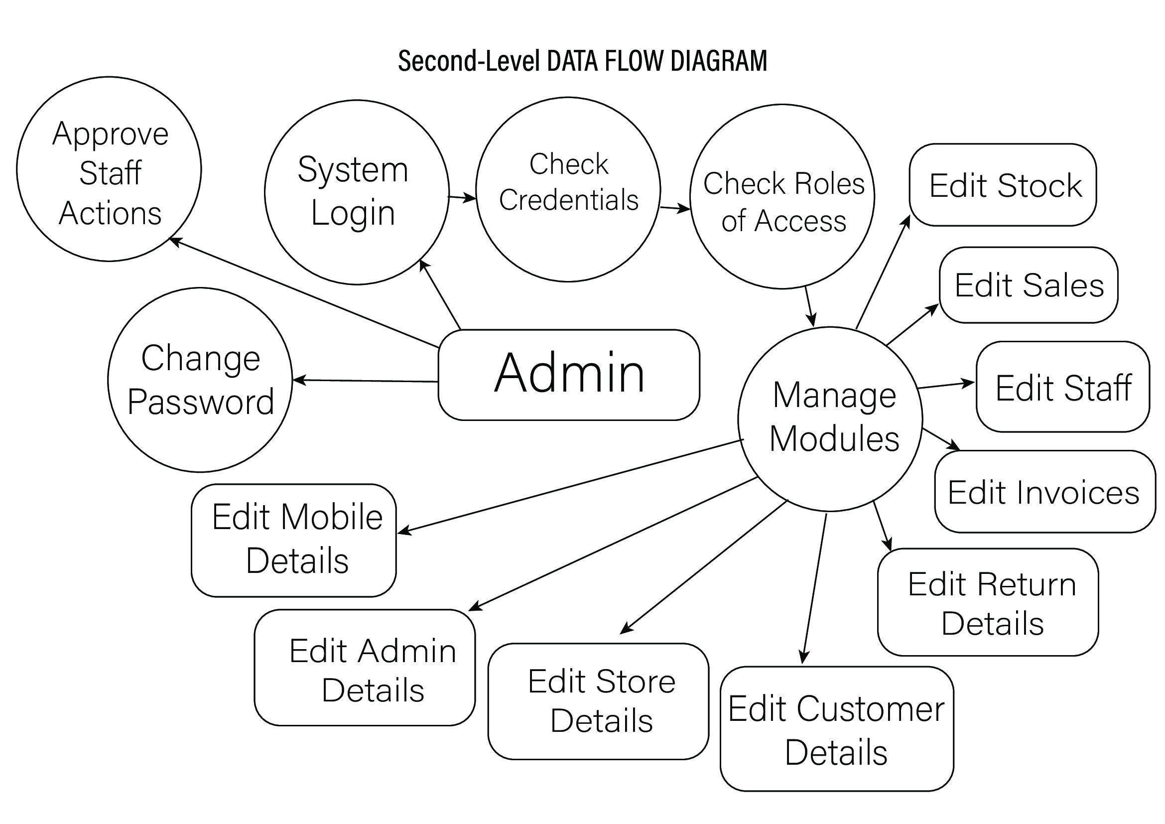

3.4 INTERFACE / INPUT DESIGN
Login Page
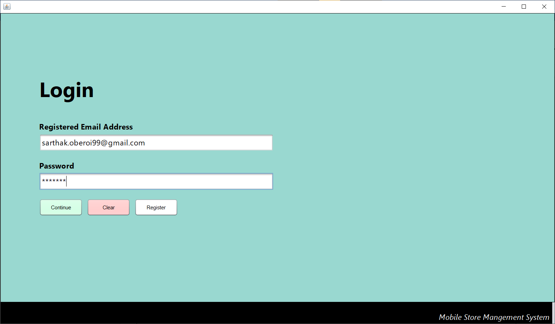
Main Menu (For Staff)
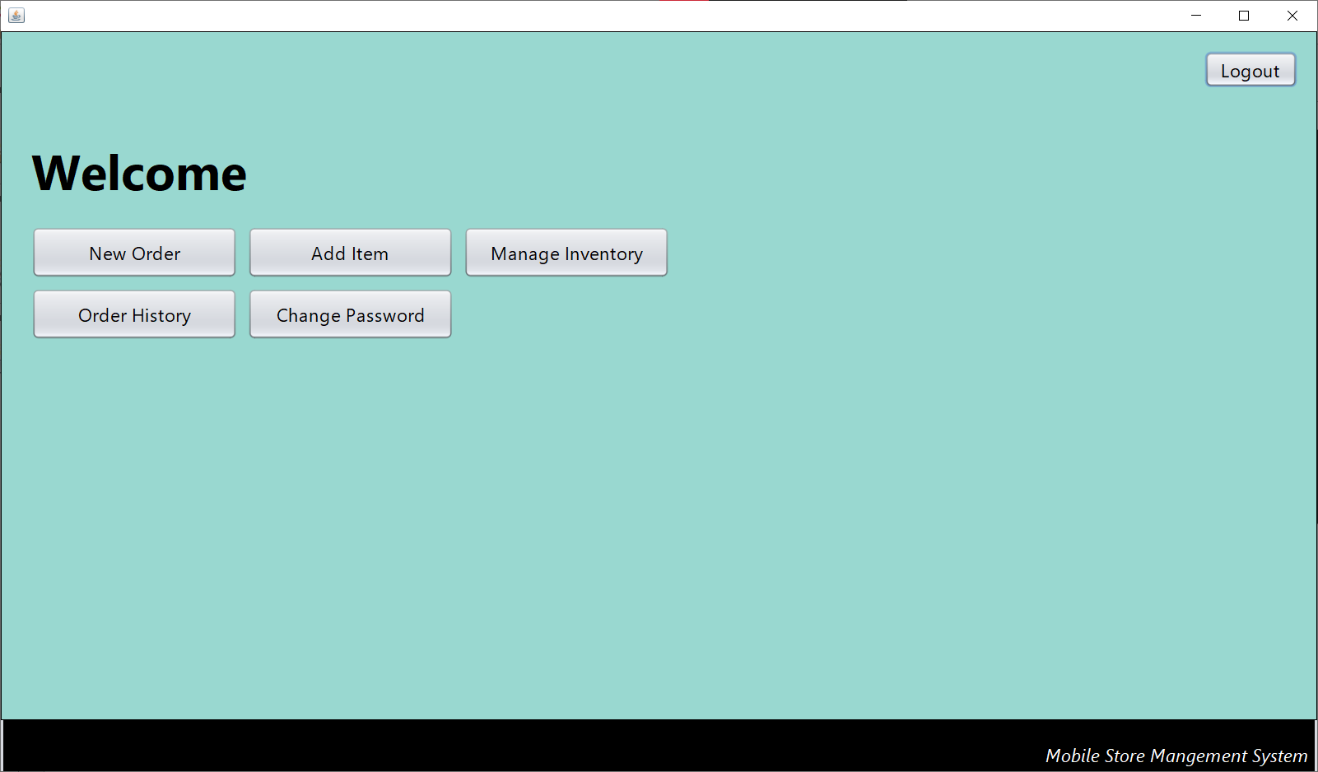

Main Menu (For Administrator)
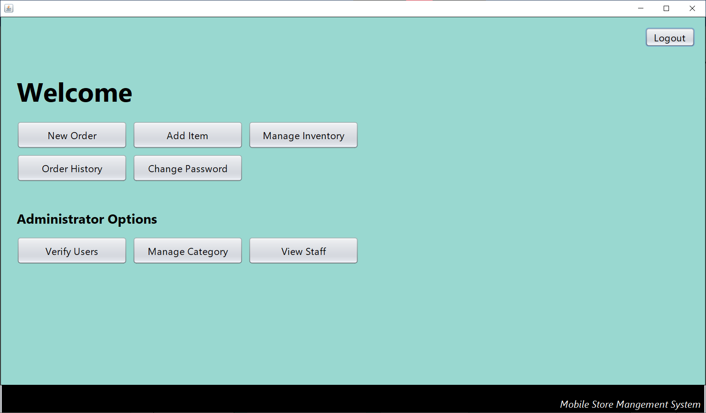
New Order
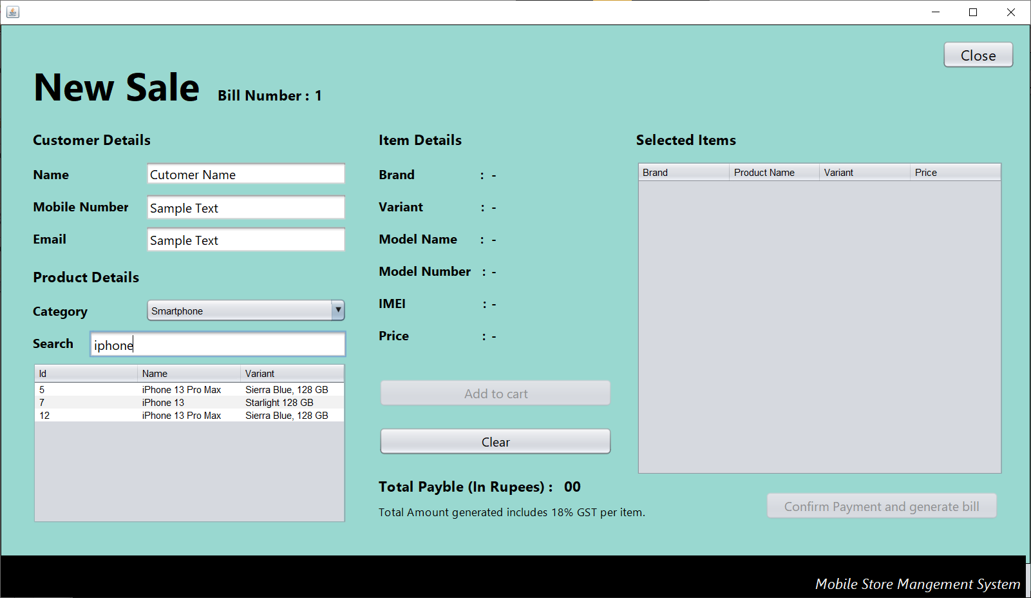

Add Item
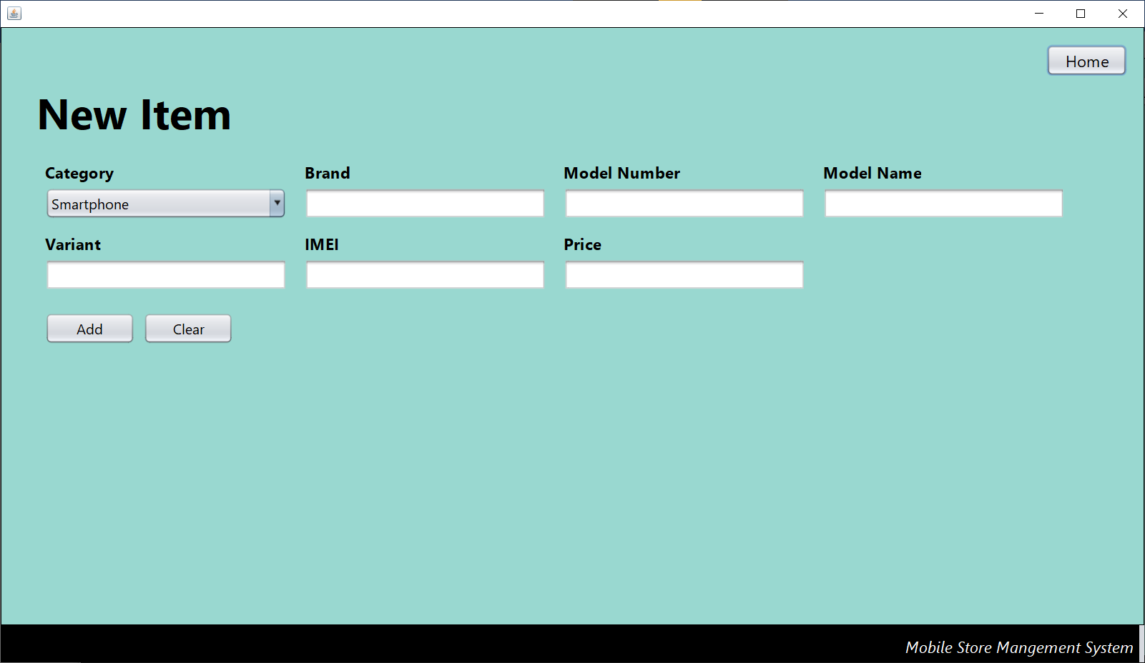
Manage Inventory
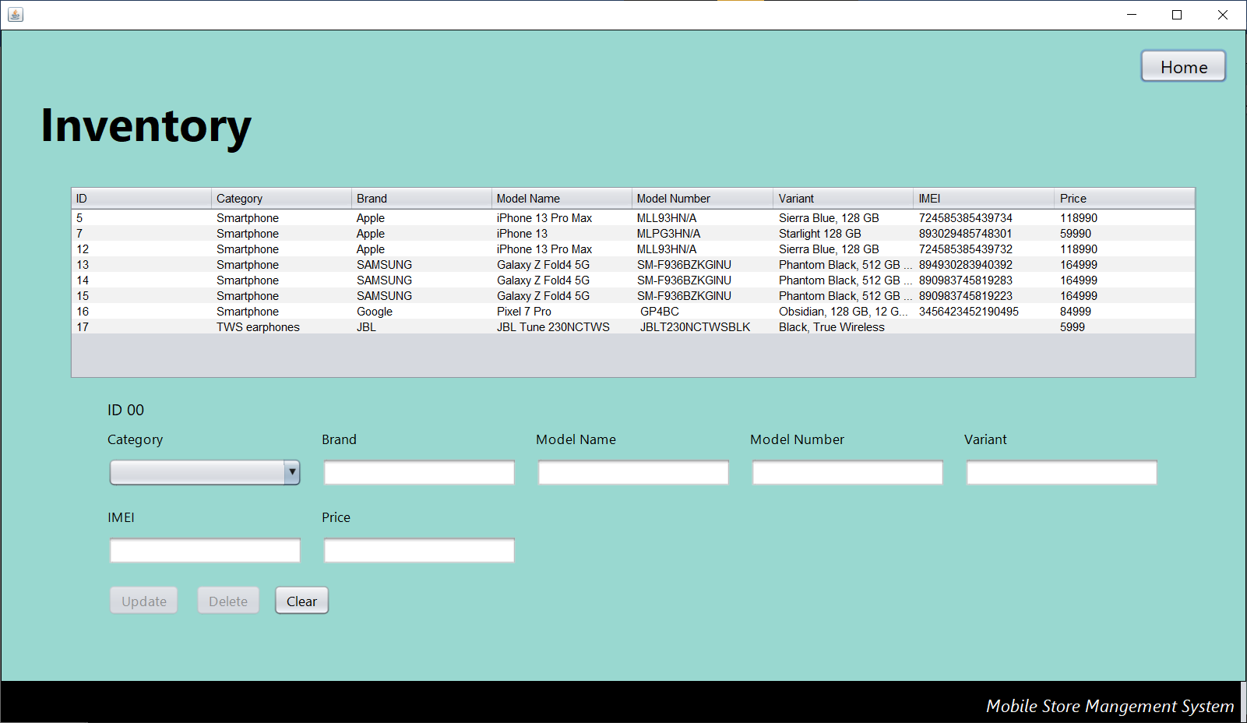
Verify Users (Administrator)
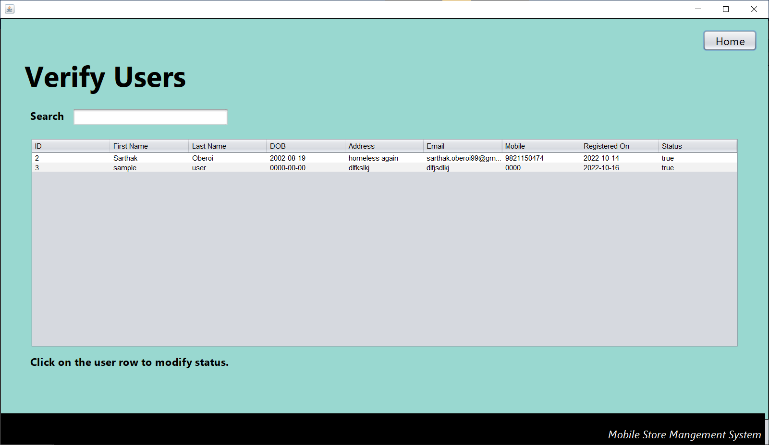
Manage Categories (Administrator)
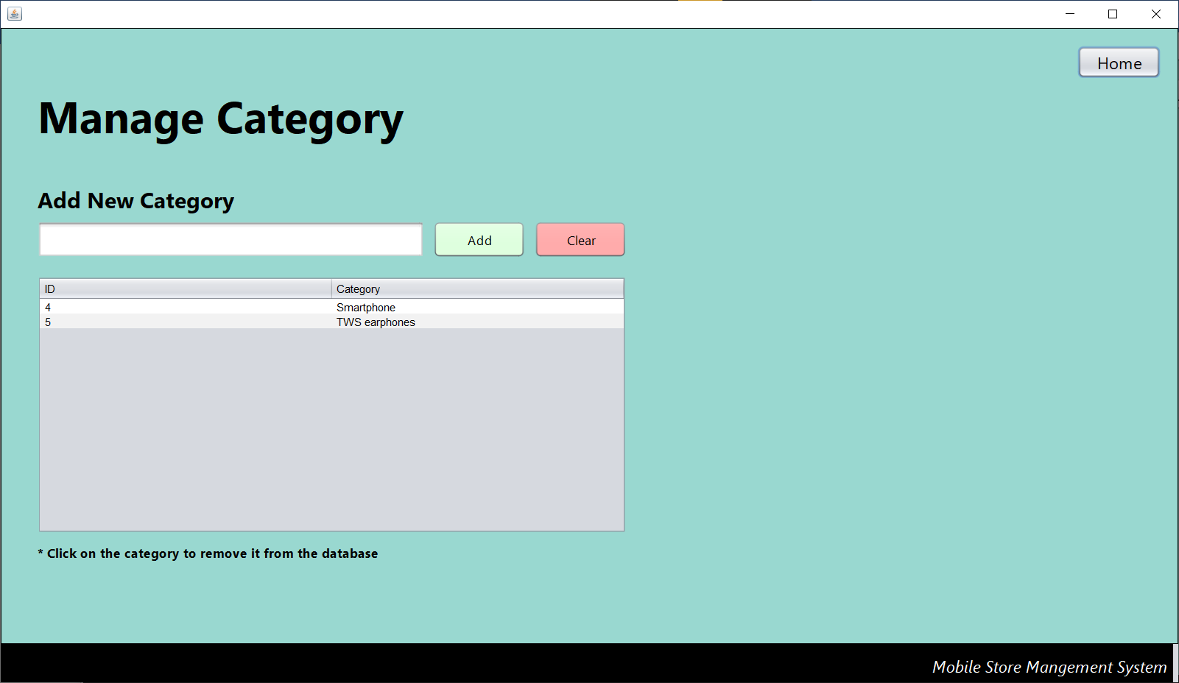

View Staff (Administrator)
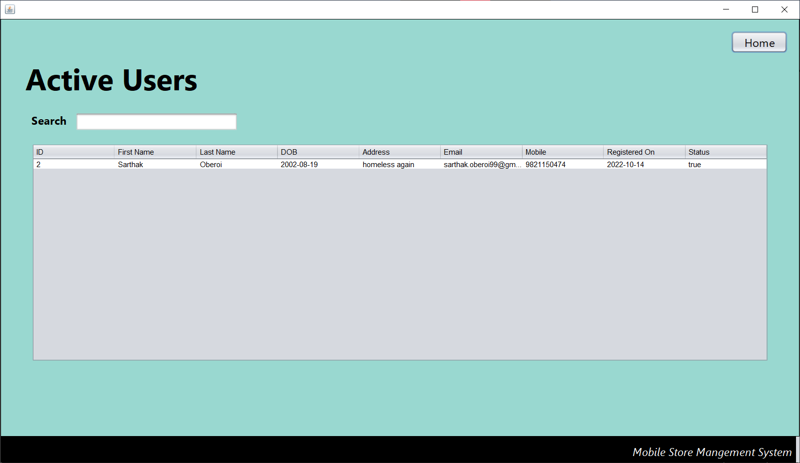
Order History
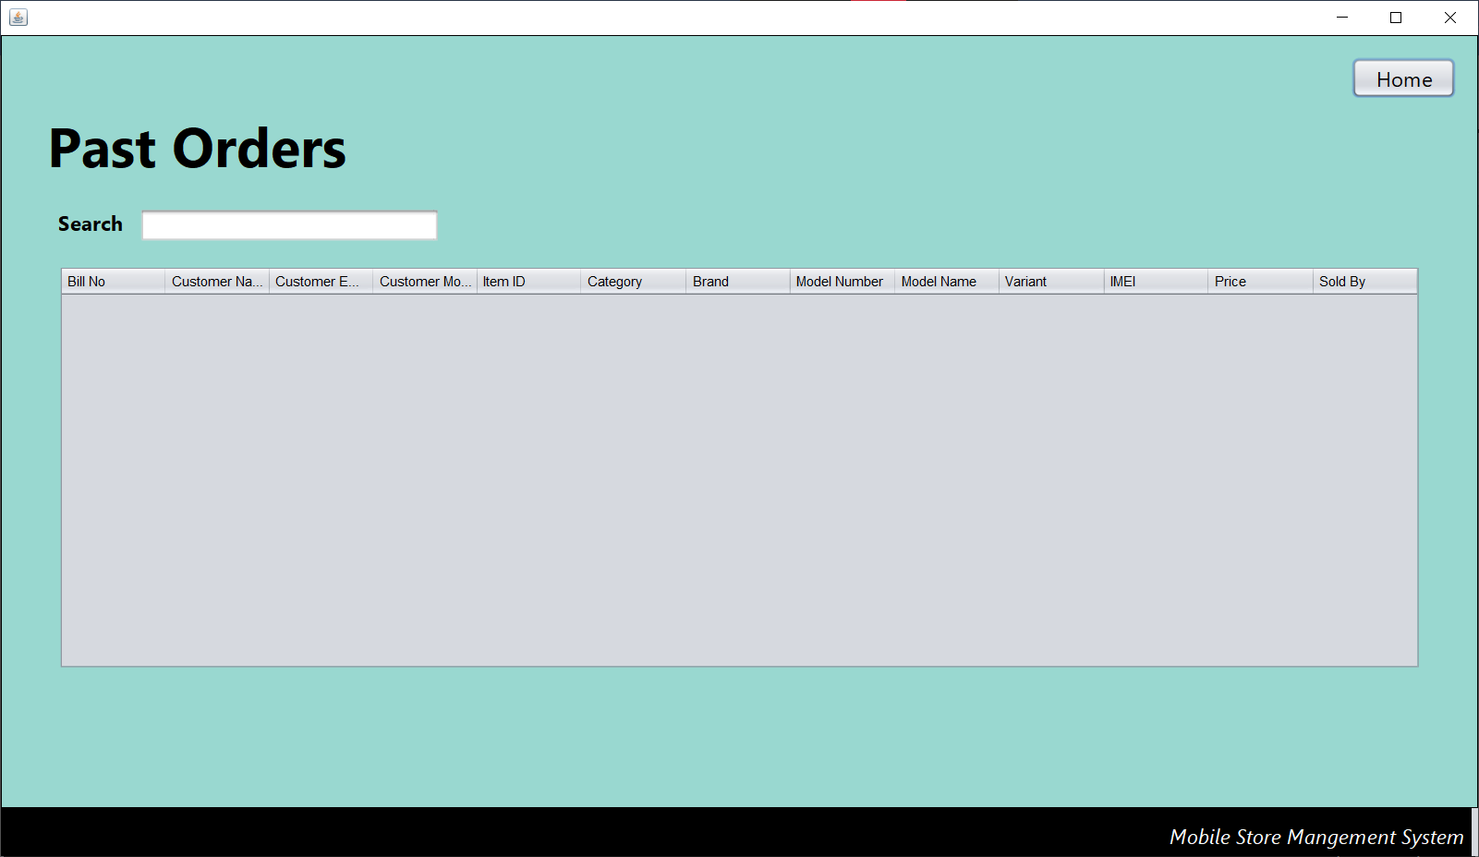

Change Password
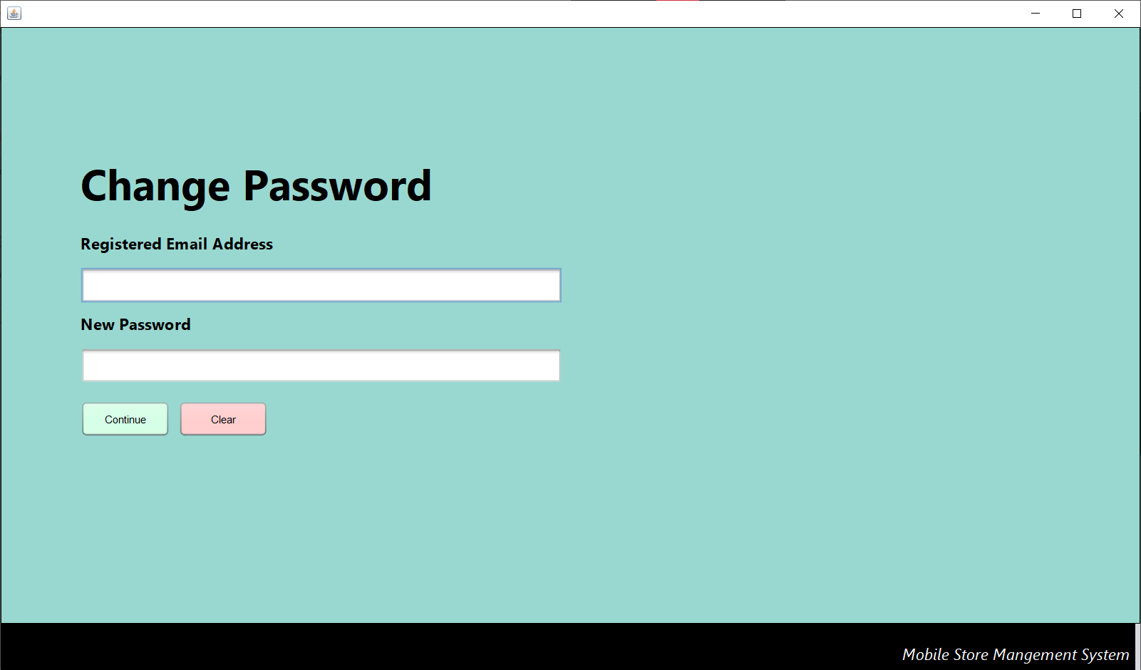

3.5 OUTPUT DESIGN
Login Page
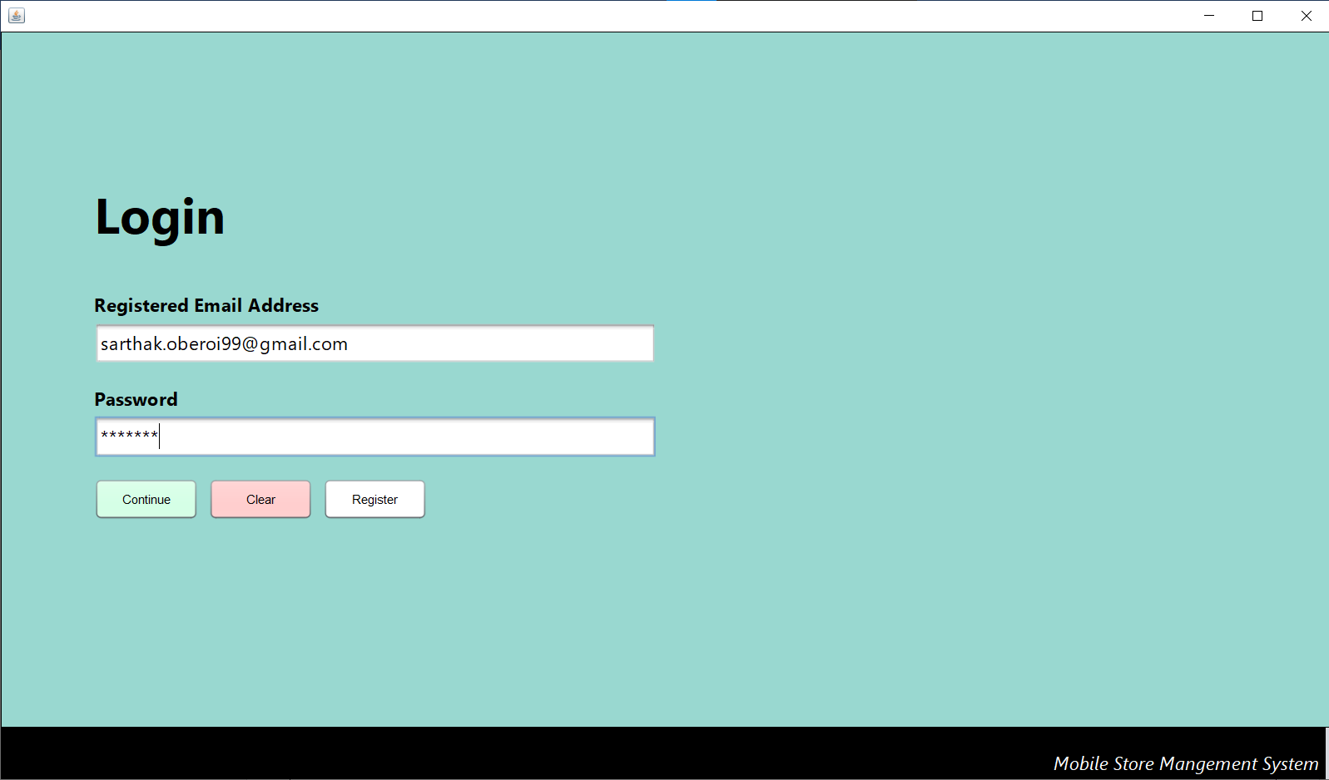
Signup Page
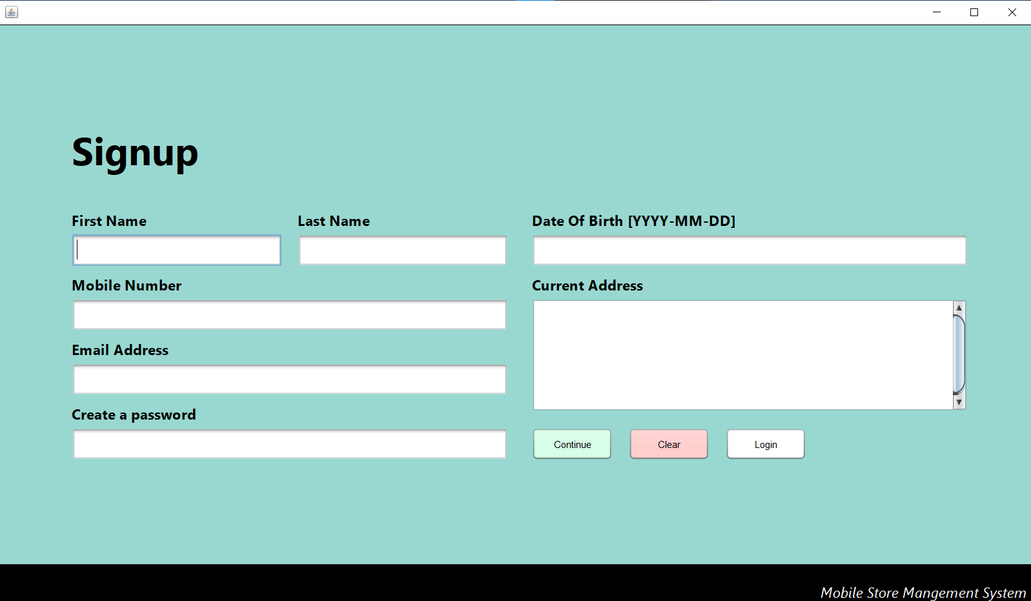

New Order
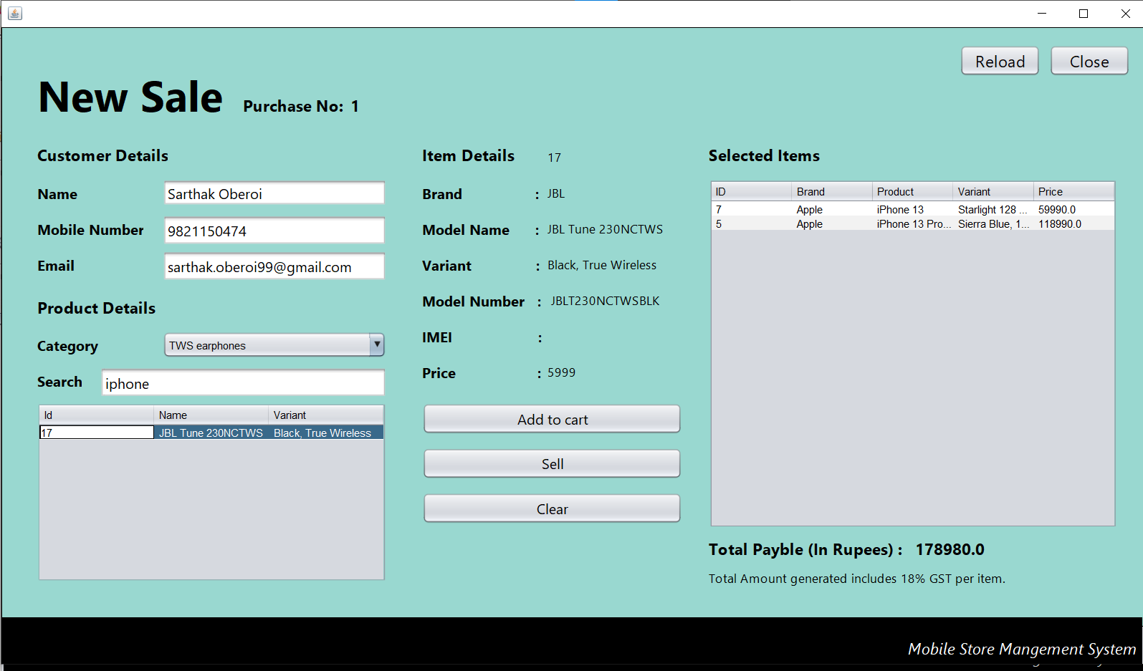
New Item
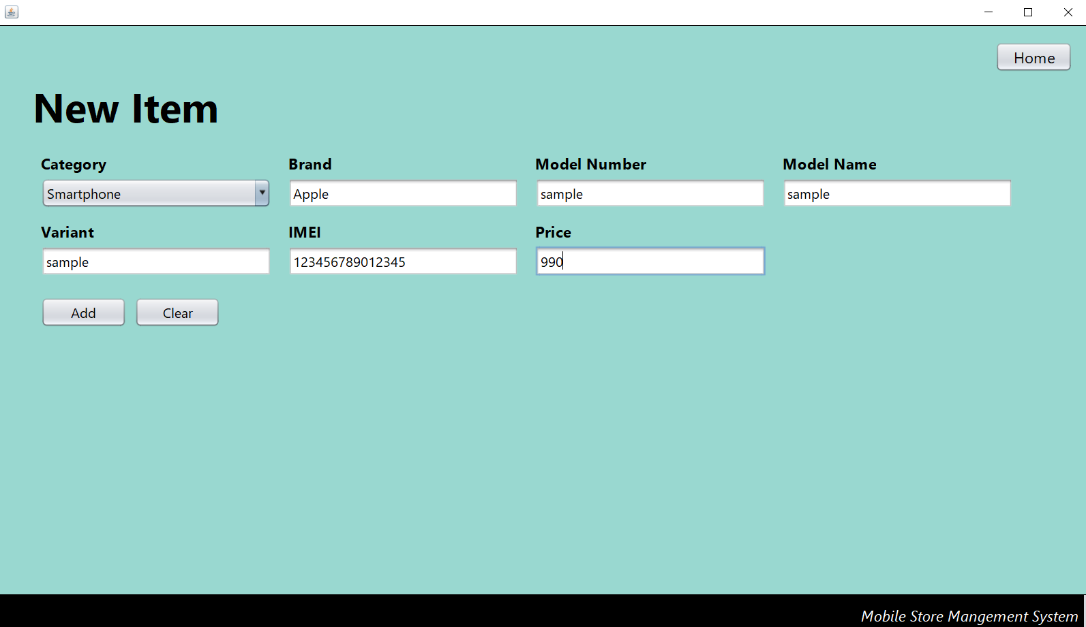

Inventory Management
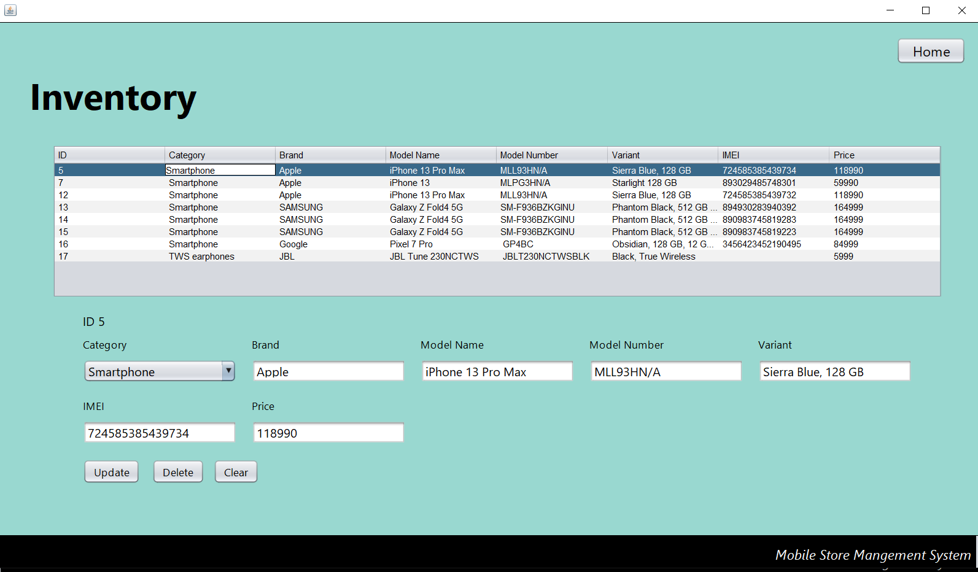
Change Password
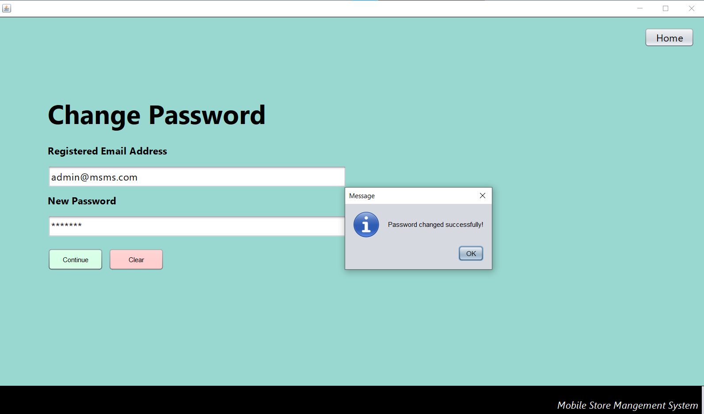

Change Status of user (Verify)
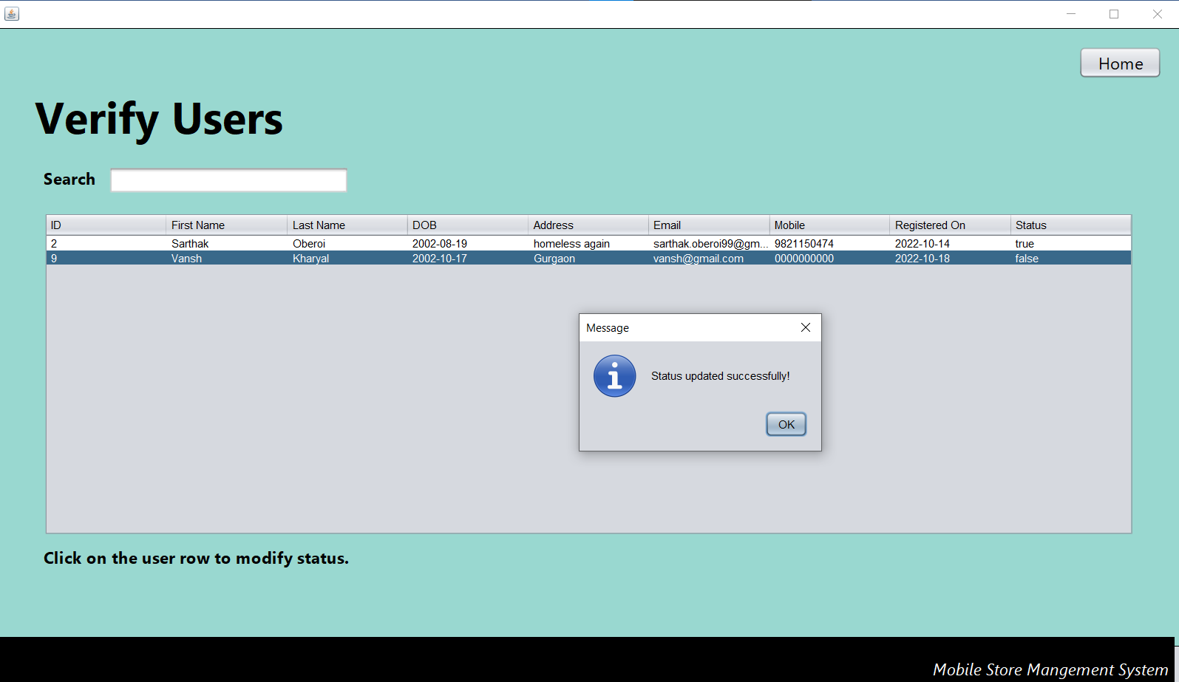
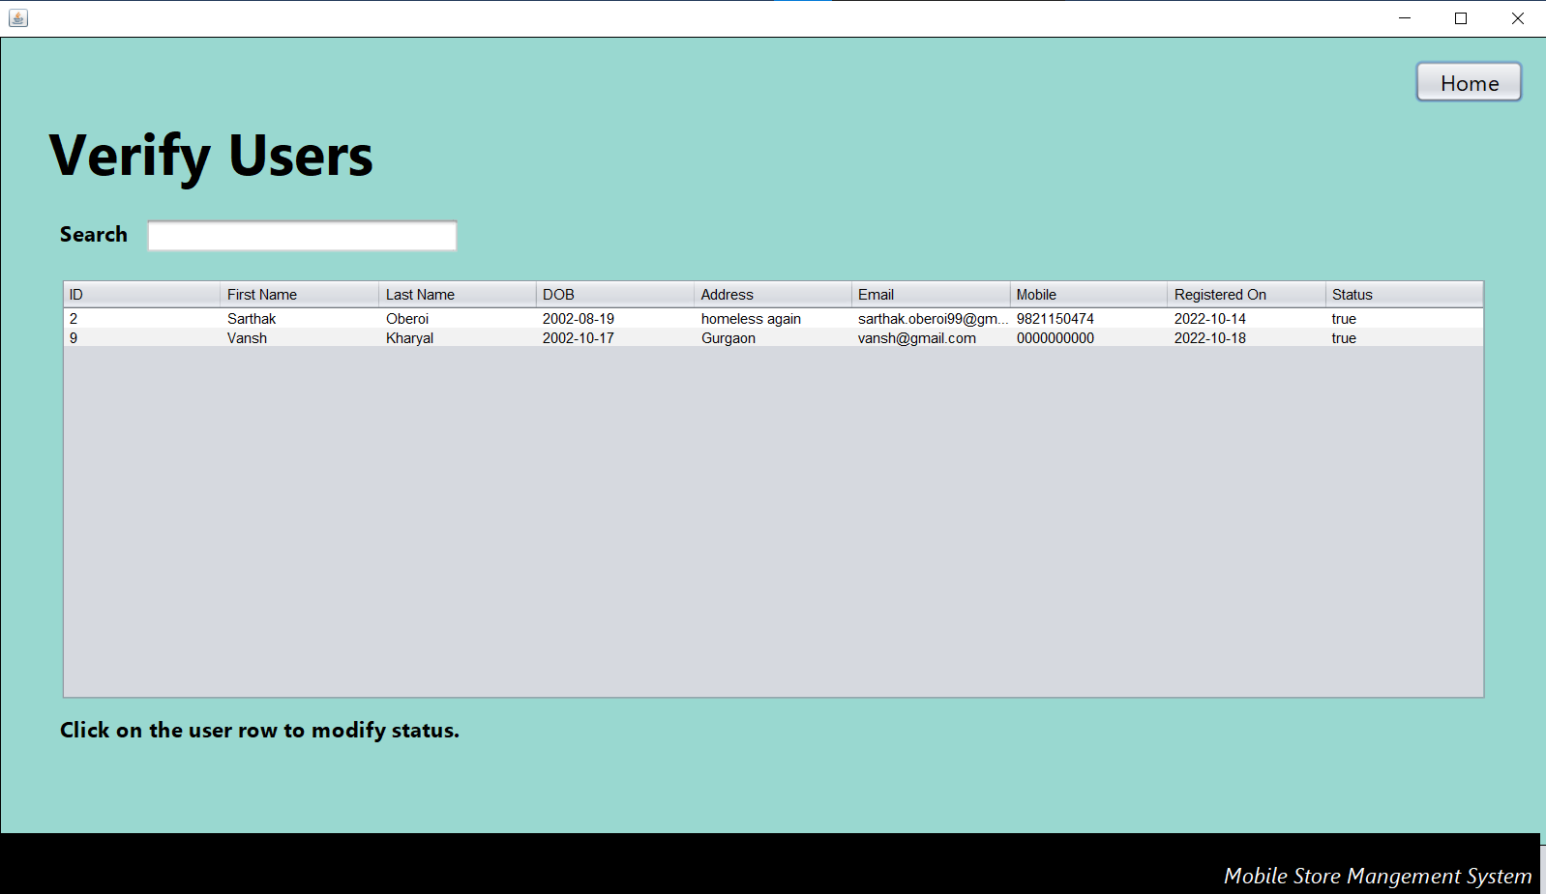

Manage Category
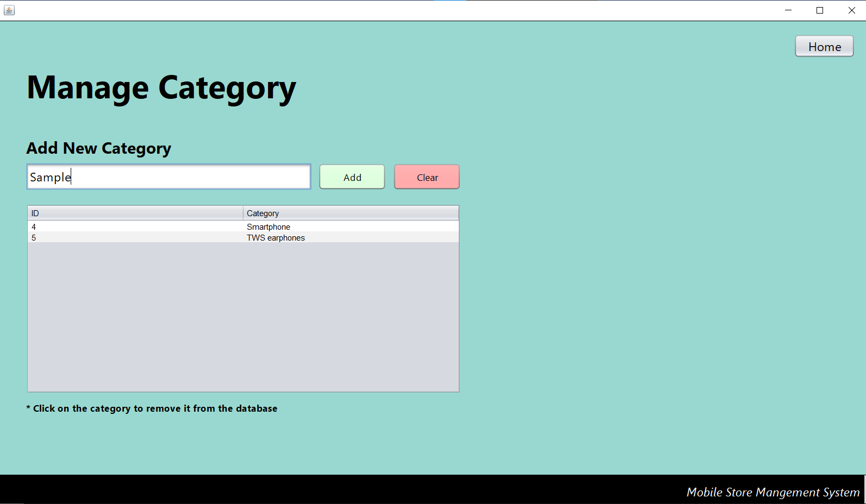
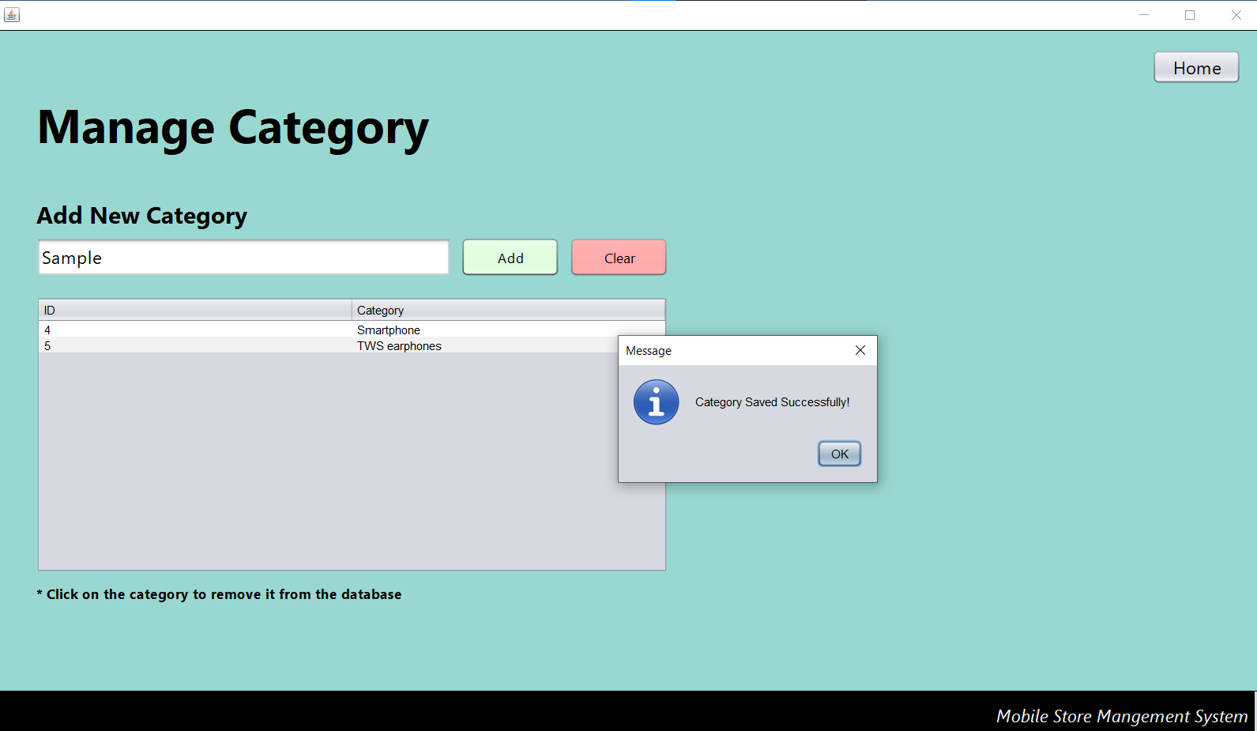
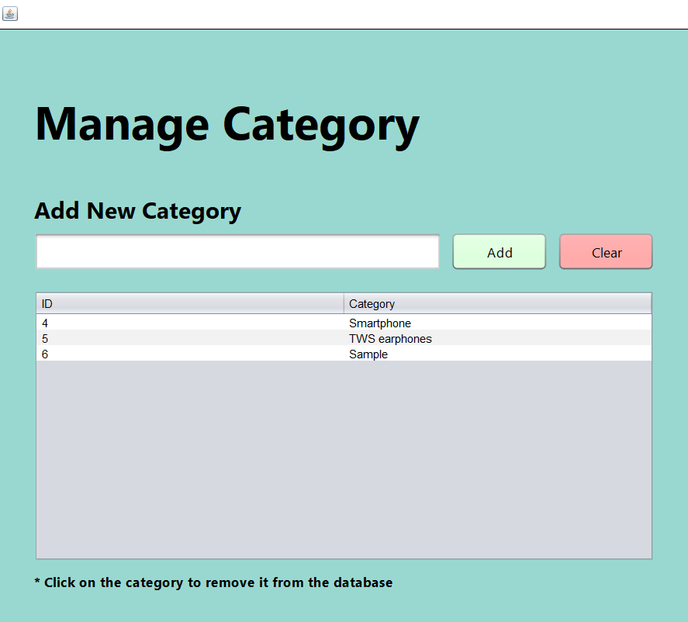
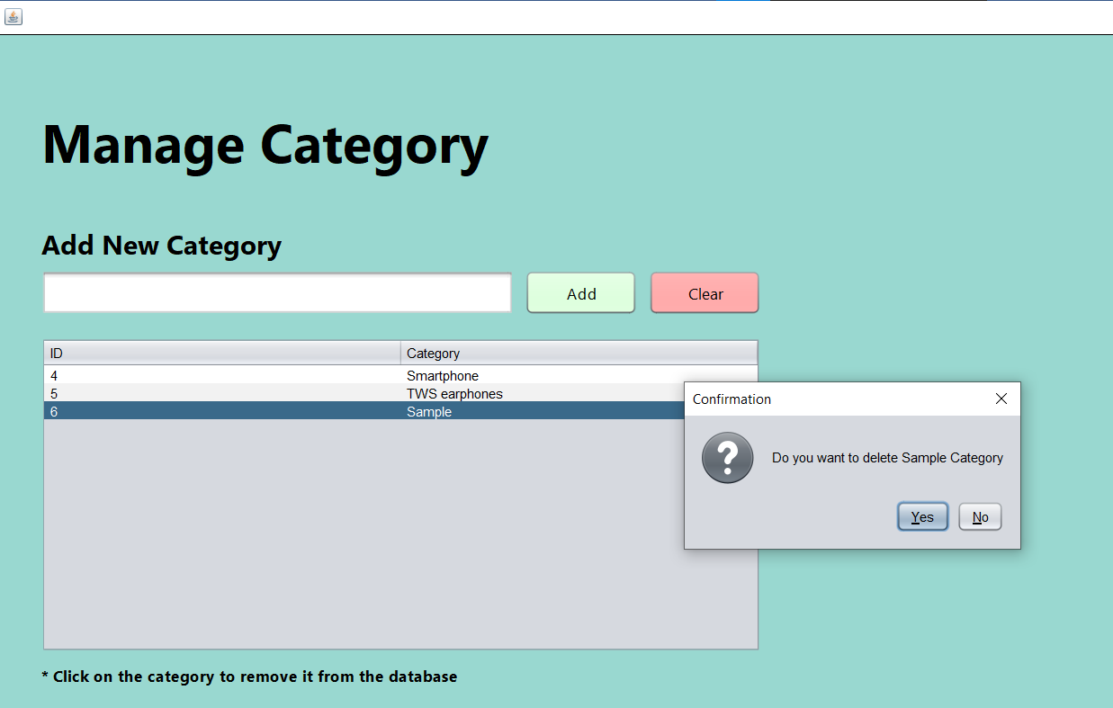
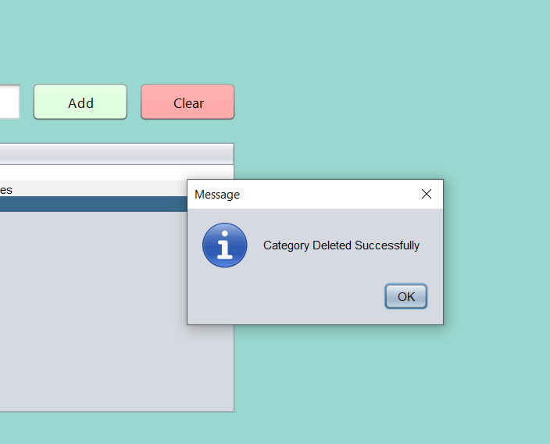
Manage Inventory
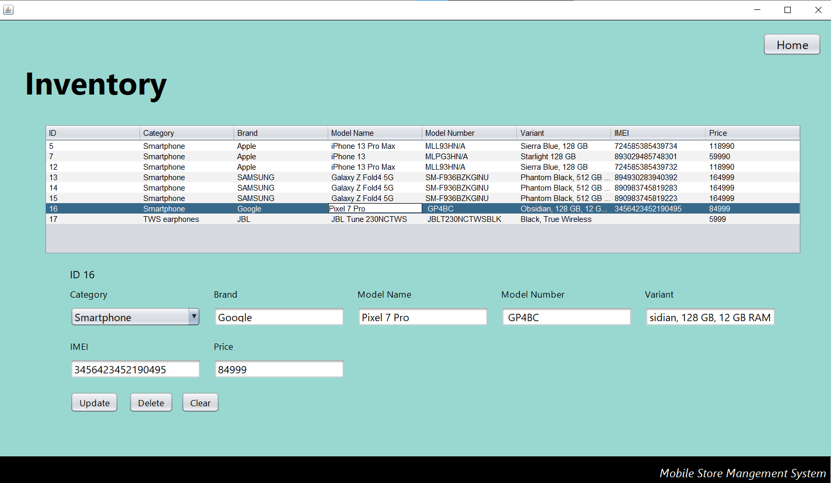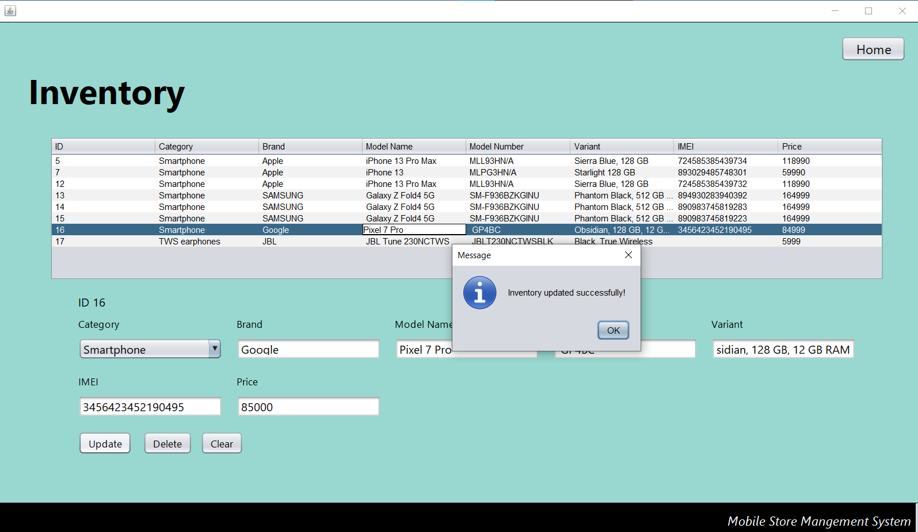

View Active Users
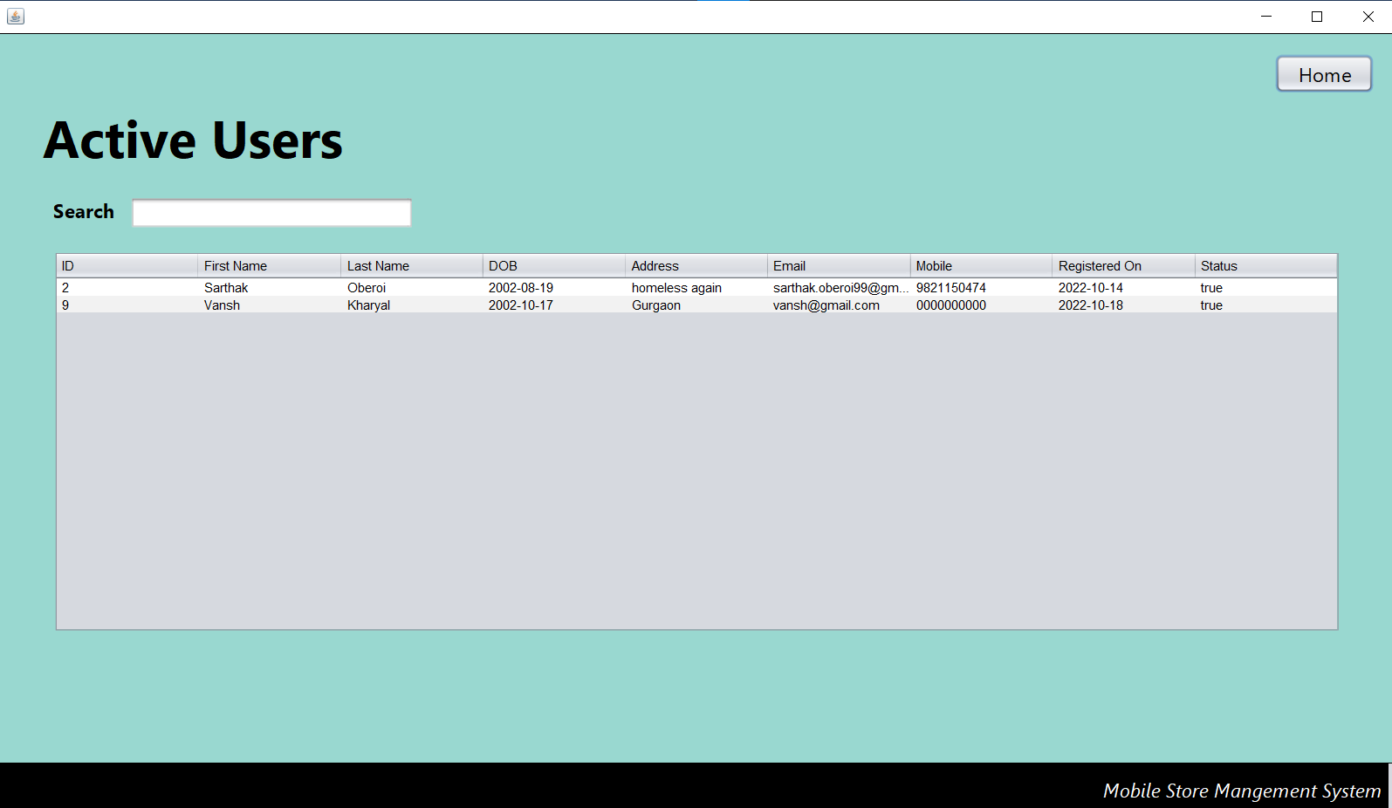

CHAPTER 4
TESTING AND IMPLEMENTATION

4.1 TESTING METHODOLOGY

UNIT TESTS
This is the most basic testing mechanism. It consists of a well-defined scope. We avoid the code from outside interaction. Unit tests focus on the small unit of functionality. There is the interaction of the code with memory only and no interaction with network, database or file systems.

They provide a simple way to check the smallest units of code and prove that units can work efficiently. However, we need to check that when these units are combined, they work in a characterised manner which leads to different types of tests.

INTEGRATION TESTS
Integration test is the second type of testing mechanism. Integration tests involve testing of the modules which access networks, databases and file systems. They reveal the issues with network modules or databases and between small units of codes. Also, when the units are connected together there might be issues. Module 1 might not be giving data properly to the module 2 and these issues come up in the integration tests.

SYSTEM TESTS
System Testing is a type of software testing that is performed on a complete integrated system to evaluate the compliance of the system with the corresponding requirements.

In system testing, integration testing passed components are taken as input. The goal of integration testing is to detect any irregularity between the units that are integrated together. System testing detects defects within both the integrated units and the whole system. The result of system testing is the observed behaviour of a component or a system when it is tested.
4.2 TESTING METHODOLOGY APPLIED

UNIT TESTS
As we know that unit testing is the most common testing mechanism, and it covers a very narrow and well-defined scope, so it was easy for me to understand and use it for my code.

Unit tests cover only memory and not the database and it also checks even the smallest unit of code and checks whether there is any error in the code or not.

4.3 TEST CASES
4.3.1 Test cases table
Test Cases | Sample Input | Sample Output | Interpretations
1. | Signup Page, Incorrect Date Format | Error output, handled by try, catch statements. | Test Case Successful
2. | Login Page, entered incorrect password | Login Unsuccessful | Test Case Successful
3. | Incorrect Price | Shows error and clears the field. | Test Case Successful
4. | Trying to open homepage without login | Code error – sign of good security | Test Case Successful
5. | No item selected in new order | Add to cart button disabled | Test case Successful

4.3.2 CHARACTERISTICS OF TEST CASES
- It is accurate.
- It is economical.
- It is reusable.
- It is used to perform the test over and over.
4.3.3 TEST CASE SCREENSHOTS
Incorrect date of birth format in signup
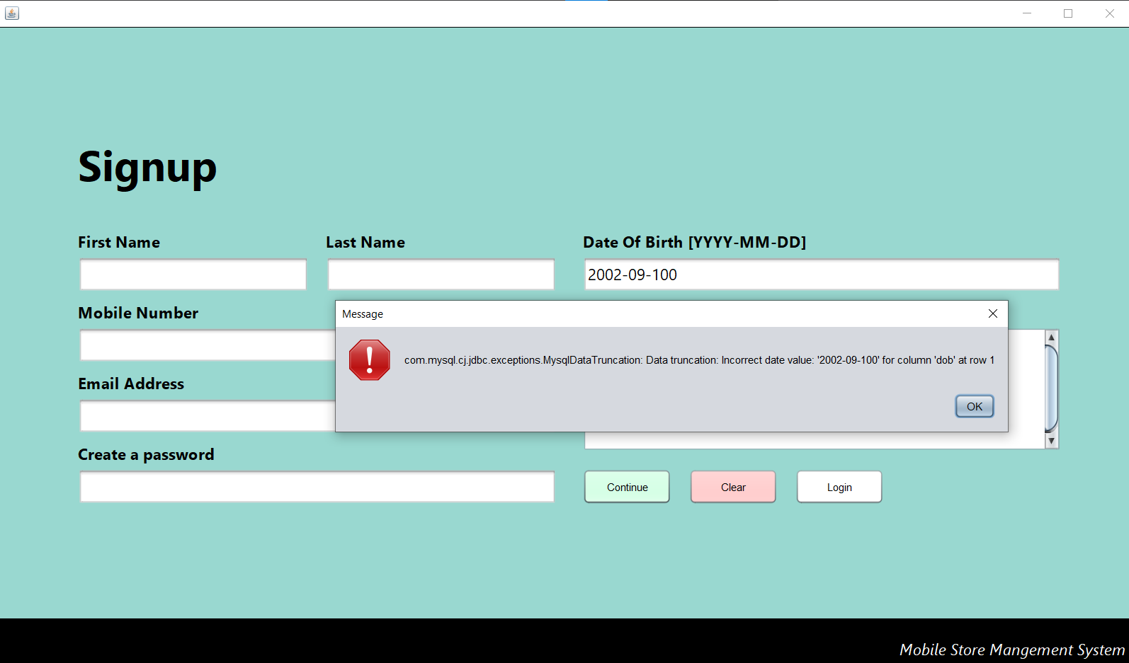
Incorrect Details / Unapproved user
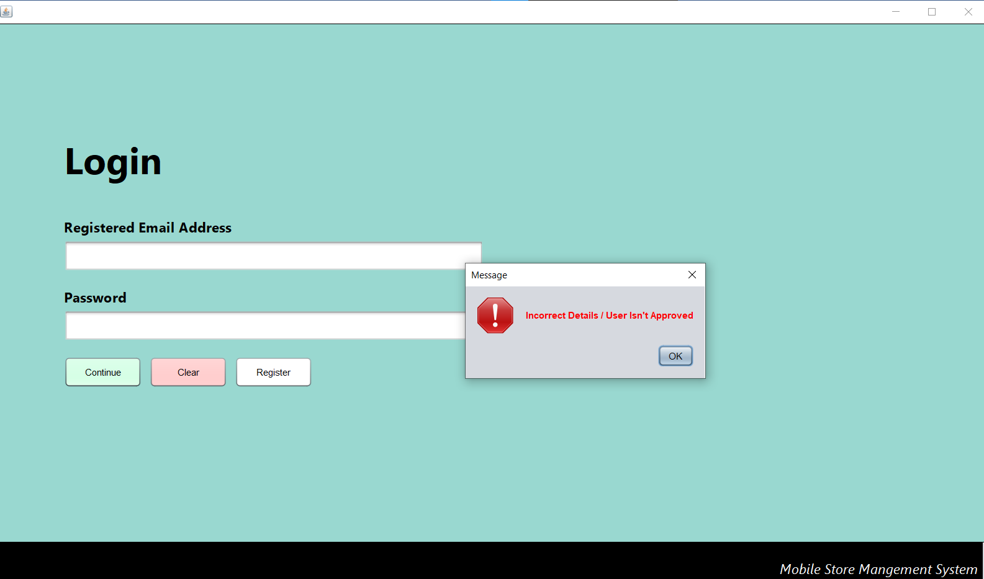

Incorrect Price Details – New Item
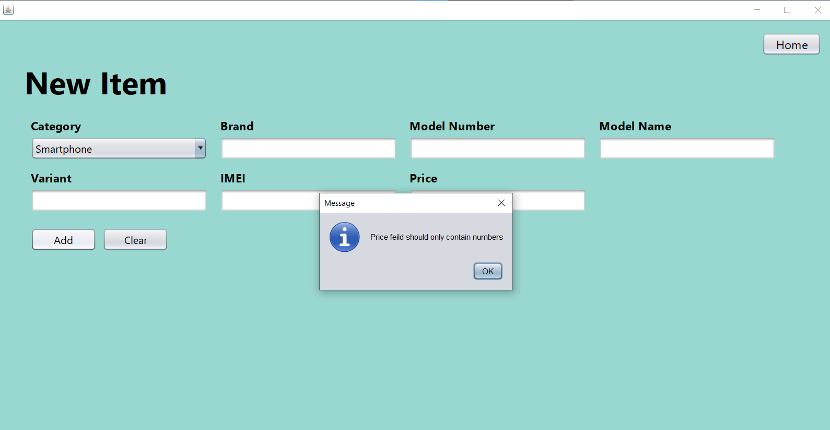

Trying to open homepage without login
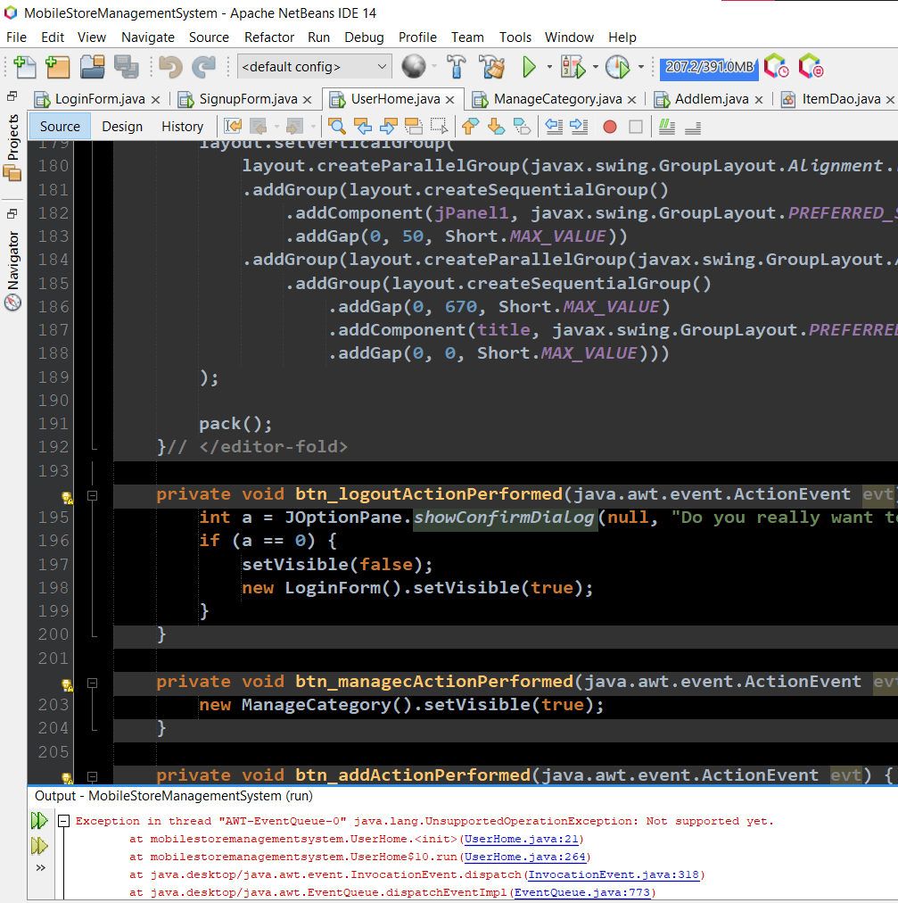
Add to cart button disabled when no item selected in new order
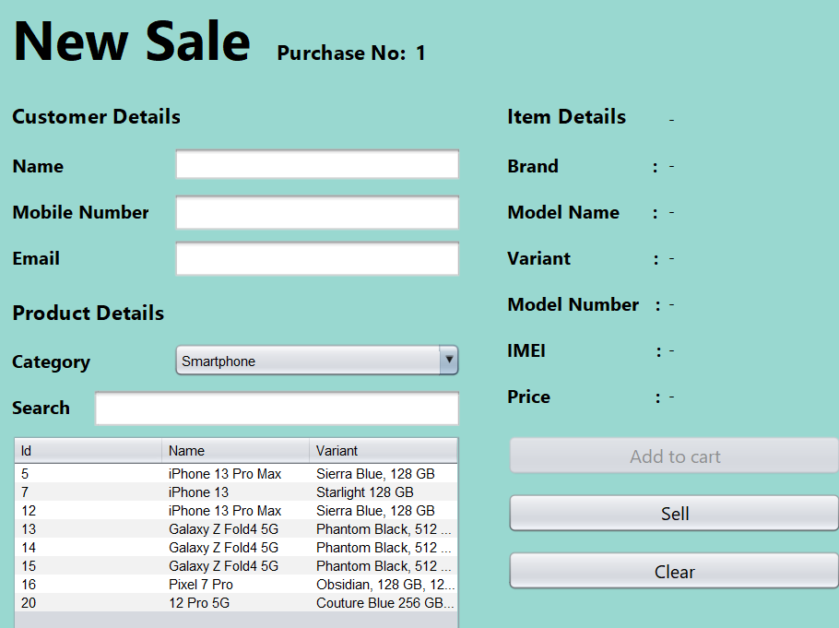
4.4 TEST DATA

Test data is exactly the input given to a software program. It represents data that affects or is affected by the implementation of the specific module. Some data may be used for positive testing, typically to check that a given set of input to a given function produces a predicted result. Other data may be used for negative testing to test the capacity of the program to handle unusual, extreme, exceptional, or unexpected input. Poorly designed testing data may not test all possible test scenarios which will prevent the quality of the software.

4.5 GAP ANALYSIS

GAP ANALYSIS refers to the process through which a company compares its actual performance with its expected performance to determine whether it is meeting the expectations and using its resources effectively.
Gap analysis defines the current state of the company or organisation and the target state of the same company or organisation. By defining and analysing these gaps, a business management team can create an action plan to move the organisation forward and fill the gaps in performance.
The requirement for making this system was to make a system good enough to handle the inventory and large number of items coming into the store for a better management which it is doing nearly as expected but there are certain gaps which need to be filled in the coming versions of the system.

4.6 REWORK / RETEST

If the errors are occurring, it is necessary to handle it. Also, it should be retested after a specific period of time.

4.7 HARDWARE & SOFTWARE REQUIREMENTS
4.7.1 HARWARE REQUIREMENTS

- Processor - Intel Atom
- Clock speed - Up to 2.0 GHz at 2.4 W (Z550)
- System bus - 32/64 bits
- RAM - 2GB of RAM
- HDD - 8 GB

4.7.2 SOFTWARE REQUIREMENTS

- JDK
- JAR
- Net Beans IDE
- MySQL

CHAPTER 5
CONCLUSION AND REFERENCES

5.1 CONCLUSION

“As we all know that the technology is increasing day by day, very fast, we have to use these technologies to the best.”
Our system provides various services like easy access to users, efficient data management, and clear productivity also it is less time consuming etc.
Our project is a live project and it provides many facilities and benefits to the customer.

Some of them are:

- In this application, we have everything at one place. There is no need to find and go on different places/shops for purchasing different items, on our application we can have different items at one place.

- When we go on shops for purchasing items, we have to be in queue and wait for our turn, which makes the process more time consuming, but in our application, you can buy the products in lesser time as compare to the shops.
- For billing there is no need to be in any queue.

- Now-a-days, not everybody carry cash, so we want to introduce payment methods and portal for the same for make secure and seamless payments.

- We have functionality of add and drop in our app.

5.2 LIMITATION OF THE SYSTEM

“Anything which has benefits also has its disadvantages or limitations at the same time.”

Although we have put our best efforts to make software flexible, easy to operate but limitations cannot be ruled even by us.

Some of our project’s limitations are:
- There is no option to pay cash on delivery.
- Internet is compulsory to use our app.
- Except pay-tm wallet, no other wallet is in option for payment.

5.3 FUTURE SCOPE FOR MODIFICATION

Upgradation is required time to time in any software. In a brief, it can be summarized that the future scope of the project remains around maintaining the information.

- In future, we will include new vendors/brands in shopping app.
- We will include cash on delivery as a payment method.
- We will raise the security level of our app by using various technologies like send OTP for verification of mail id, fingerprint system, etc.
- We will provide customer support to the customer for any kind of query.

The aforementioned points are the scopes which can be done to increase the applicability and the usage of the work product.
We have left all the options open so that if there is any other future requirements in the system by the user for the scope of the system then it is possible to implement them.

Software scope describes the data and control to be processed, function
performance, constraints, interfaces and reliability. Function describes in the
statement of scope is evaluated and, in some case, refined to provide more detail
prior to the beginning of the estimation. Because both cost and schedule
estimates are functionally oriented, some degree of decomposition is often
useful.
We can implement easily this application. Reusability is possible as and when we
require in this application. We can update it next version. We can add new
features as and when we require. There is flexibility in all the modules. Scope of
this document is to put down the requirements, clearly identifying the
information needed by the user, the source of the information and outputs
expected from the system

It is highly likely that the scope will change as this Desktop Application can be changed to the Web Application and the web process model should be incremental. This allows the development team to “freeze” the scope for one increment so that an operational web application release can be created. The next increment may scope changes suggested by a review of the preceding increment, but once the second increment commences, scope is again frozen temporarily. This approach enables the Web App team to work without having to accommodate a continual stream of changes but still recognizes the continuous evolution characteristics of most web application. Besides that, the following basic quality in the software always safeguards the future scope of the software.

5.4 REFERENCES / BIBLIOGRAPHY

ONLINE REFERENCE
- tutorialspoint
- programiz
- w3schools
- Google

CHAPTER 6
ANNEXURE

6.1 MENU FLOW DIAGRAM

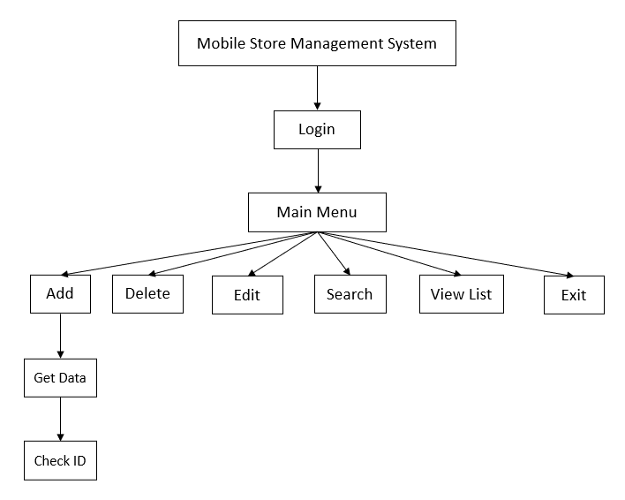
Menu flow diagram

6.2, 6.3 SAMPLE INPUT AND OUTPUT

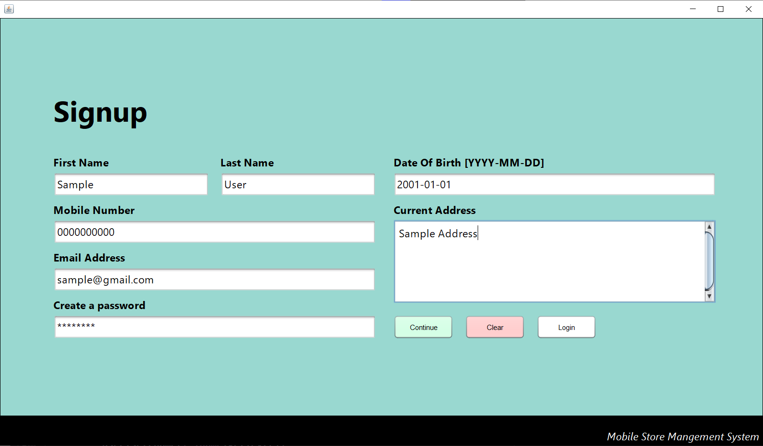
Signup Page

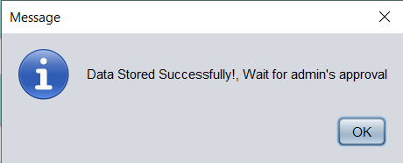
Continue button pressed – fields validate and saved to the database

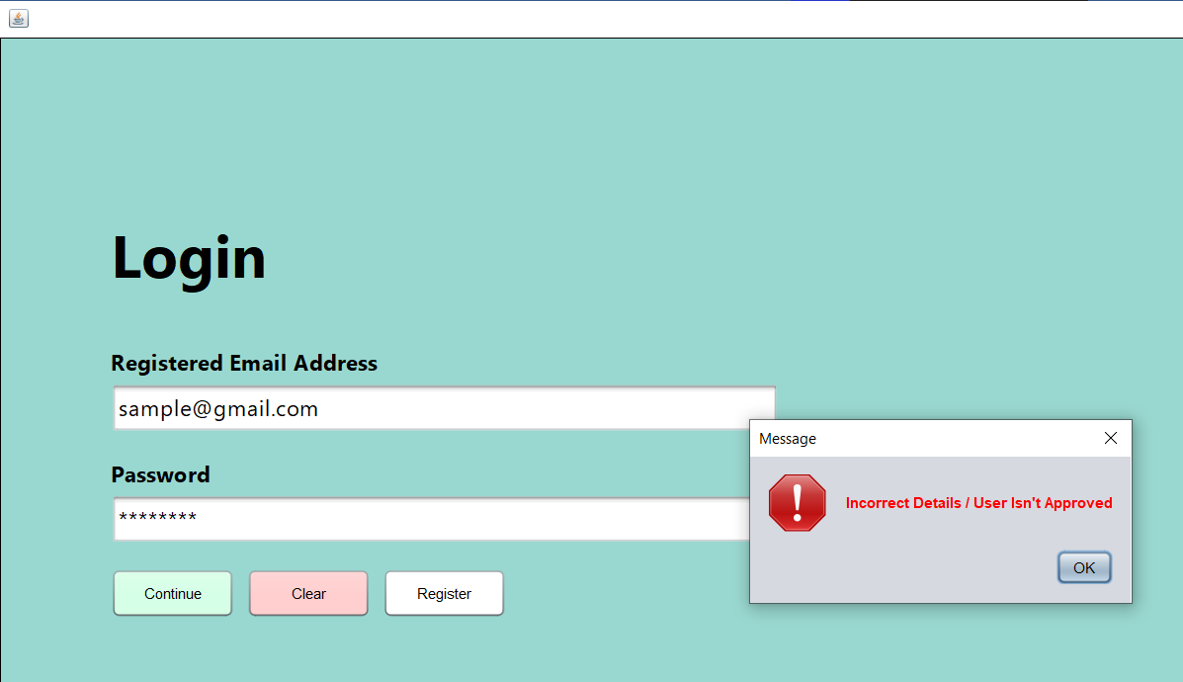
Trying to login without approval

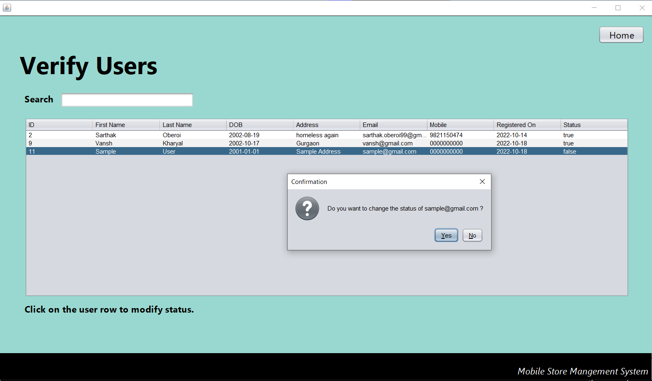

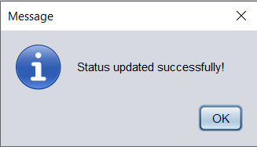

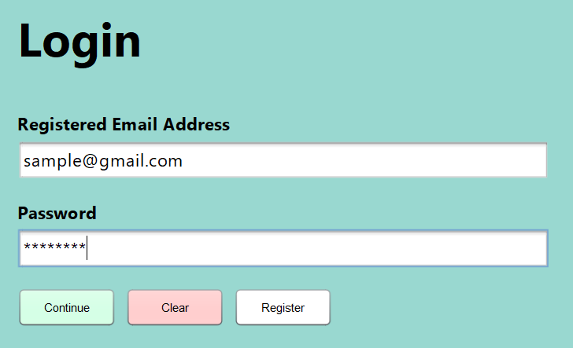
Trying to login after approval

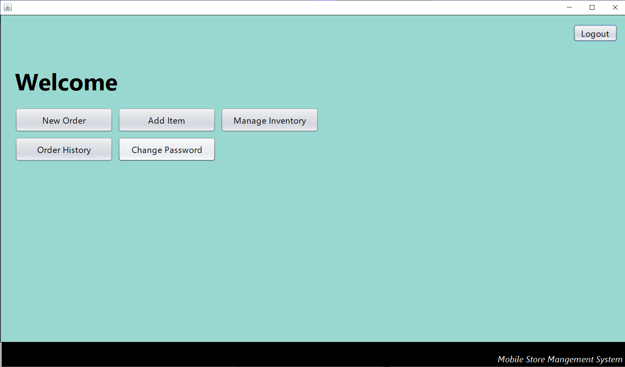
Login Successful

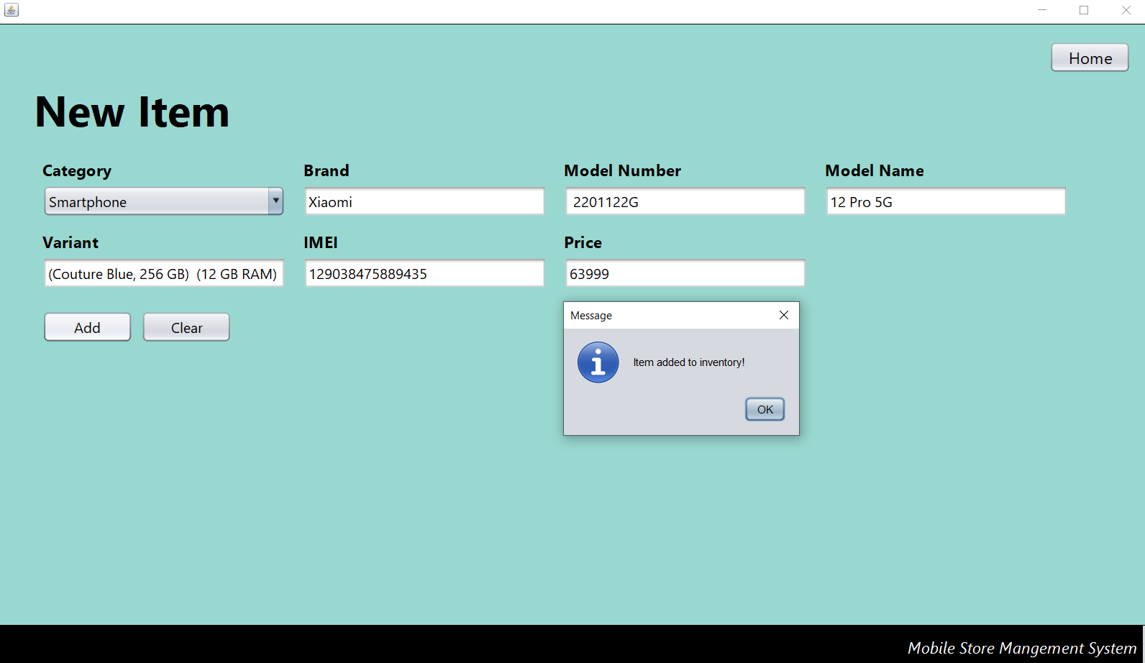
Adding new item

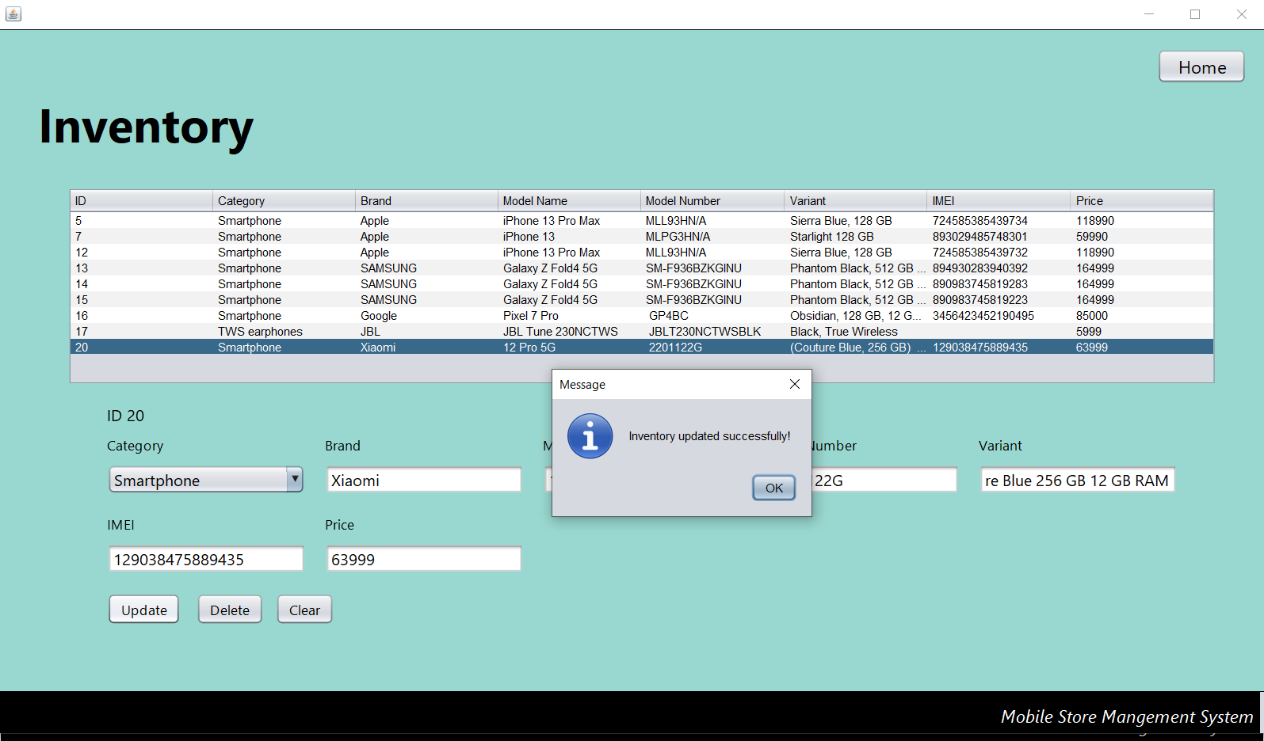
Updating order details

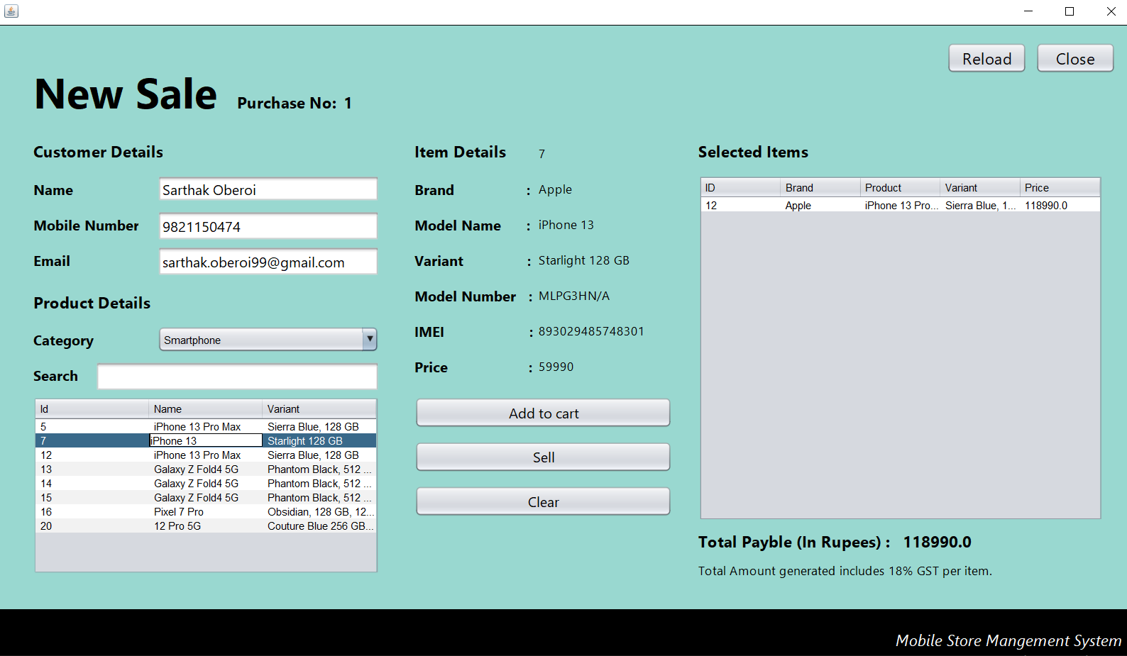

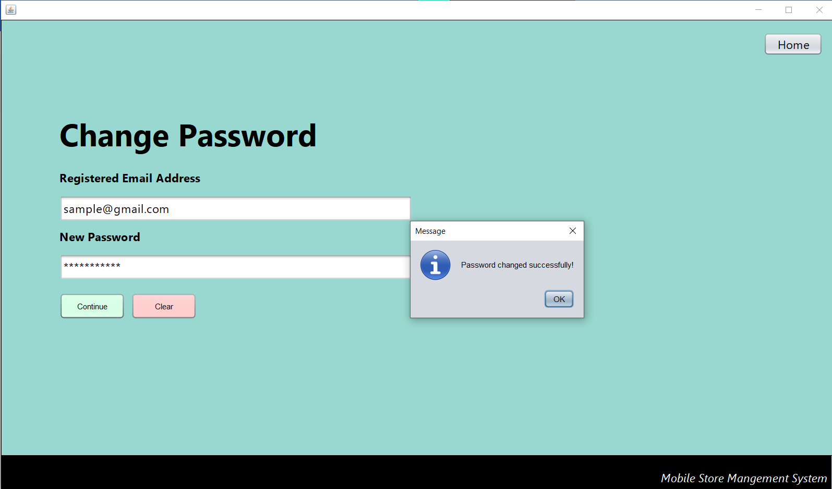
Change Password
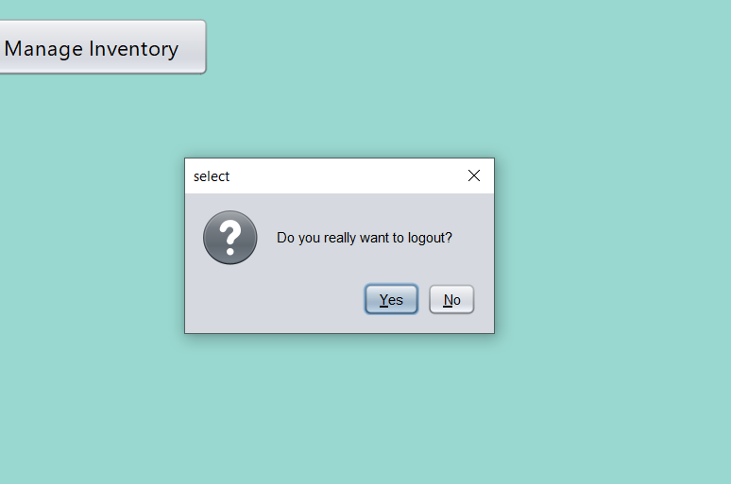
Logging out

6.4 PROGRAM CODE

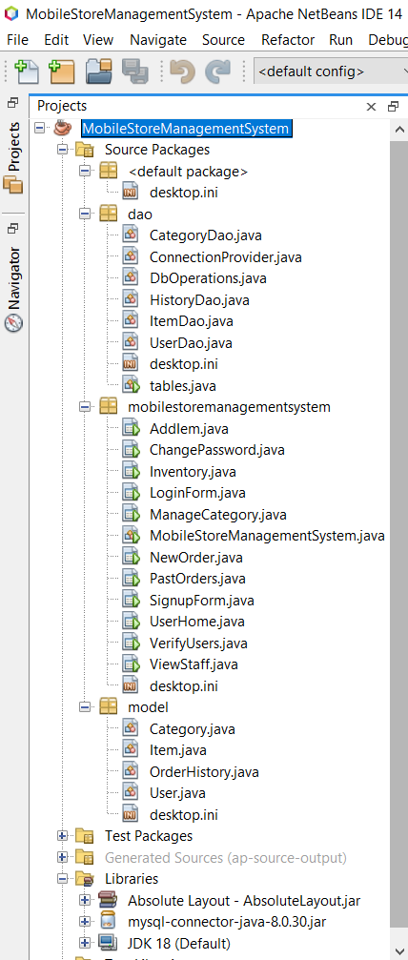
package dao;
import java.util.ArrayList;
import javax.swing.JOptionPane;
import model.Category;
import java.sql.*;

public class CategoryDao {

public static void save(Category category) {
String query = "insert into category (name) values ('"+category.getName()+"');";
DbOperations.setDateOrDelete(query, "Category Saved Successfully!");
}

public static ArrayList<Category> getAllRecords() {
ArrayList<Category> arrayList = new ArrayList<>();
try {
ResultSet rs = DbOperations.getData("select * from category;");
while(rs.next()) {
Category category = new Category();
category.setId(rs.getInt("id"));
category.setName(rs.getString("name"));
arrayList.add(category);
}
} catch (Exception e) {
JOptionPane.showMessageDialog(null, e);
}
return arrayList;

}

public static void delete(String id) {
String query = "delete from category where id='"+id+"';";
DbOperations.setDateOrDelete(query, "Category Deleted Successfully");
}
}

//ConnectionProvider.java
package dao;
import java.sql.*;

public class ConnectionProvider {
public static Connection getCon() {
try{
Connection con = DriverManager.getConnection("jdbc:mysql://localhost:3306/msms?useSSL=false","root","pass");
return con;
} catch (Exception e) {
return null;
}
}
}

DbOperations.java
package dao;

import javax.swing.JOptionPane;
import java.sql.*;

public class DbOperations {

public static void setDateOrDelete(String Query, String msg) {
try {

Connection con = ConnectionProvider.getCon();
Statement st = con.createStatement();
st.executeUpdate(Query);
if (!msg.isEmpty()) {
JOptionPane.showMessageDialog(null, msg);

}
} catch (Exception e) {

JOptionPane.showMessageDialog(null, e, "Message", JOptionPane.ERROR_MESSAGE);

}
}

public static ResultSet getData(String query) {
try {

Connection con = ConnectionProvider.getCon();
Statement st = con.createStatement();
ResultSet rs = st.executeQuery(query);
return rs;

} catch (Exception e) {

JOptionPane.showMessageDialog(null, e, "Message", JOptionPane.ERROR_MESSAGE);
return null;
}
}
}

HistoryDao.java
package dao;

import java.sql.*;
import java.util.ArrayList;
import javax.swing.JOptionPane;
import model.OrderHistory;
import model.User;

public class HistoryDao {

public static String getBillno() {
int id = 1;
try {
ResultSet rs = DbOperations.getData("select max(billno) from bills");
if (rs.next()) {
id = rs.getInt(1);
id = id + 1;
}
} catch (Exception e) {
JOptionPane.showMessageDialog(null, e);
}

return String.valueOf(id);
}

public static void save(OrderHistory bill) {
String query = "insert into bills values('" + bill.getBillno() + "','" + bill.getCustomername() + "','" + bill.getCustomeremail() + "','" + bill.getCustomermobile() + "','" + bill.getItemid() + "','" + bill.getCategory() + "','" + bill.getBrand() + "','" + bill.getModelnumber() + "','" + bill.getModelname() + "','" + bill.getVariant() + "','" + bill.getImei() + "','" + bill.getPrice() + "','" + bill.getSellerid() + "');";
DbOperations.setDateOrDelete(query, "Data saved successfully!");
}

ItemDao.java
package dao;

import com.mysql.cj.protocol.Resultset;
import java.util.*;
import javax.swing.JOptionPane;
import model.Item;
import java.sql.*;

public class ItemDao {

public static void save(Item item) {
String query = "insert into item (category, brand, modelnumber, modelname, variant, imei, price) values ('" + item.getCategory() + "','" + item.getBrand() + "','" + item.getModelnumber() + "','" + item.getModelname() + "','" + item.getVariant() + "','" + item.getImei() + "','" + item.getPrice() + "');";
DbOperations.setDateOrDelete(query, "Item added to inventory!");
}

public static ArrayList<Item> getAllRecords() {
ArrayList<Item> arrayList = new ArrayList<>();
try {
ResultSet rs = DbOperations.getData("select * from item;");
while (rs.next()) {
Item item = new Item();
item.setId(rs.getInt("id"));
item.setCategory(rs.getString("category"));
item.setBrand(rs.getString("brand"));
item.setModelname(rs.getString("modelname"));
item.setModelnumber(rs.getString("modelnumber"));
item.setVariant(rs.getString("variant"));
item.setImei(rs.getString("imei"));
item.setPrice(rs.getInt("price"));
arrayList.add(item);
}
} catch (Exception e) {
JOptionPane.showMessageDialog(null, e);
}
return arrayList;
}

public static void update(Item item) {
String query = "update item set category='" + item.getCategory() + "',brand='" + item.getBrand() + "',modelname='" + item.getModelname() + "',modelnumber='" + item.getModelnumber() + "',variant='" + item.getVariant() + "', price='" + item.getPrice() + "', imei='" + item.getImei() + "' where id='" + item.getId() + "';";
DbOperations.setDateOrDelete(query, "Inventory updated successfully!");
}

public static void delete(int id) {
String query = "delete from item where id='" + id + "'";
DbOperations.setDateOrDelete(query, "Product deleted successfully");
}

public static void stat(String name, String variant) {

}

public static ArrayList<Item> getAllRecordsByCategory(String category) {
ArrayList<Item> arrayList = new ArrayList<>();
try {
ResultSet rs = DbOperations.getData("select * from item where category='" + category + "'");
while (rs.next()) {
Item item = new Item();
item.setModelname(rs.getString("modelname"));
item.setVariant(rs.getString("variant"));
item.setId(rs.getInt("id"));
arrayList.add(item);
}
} catch (Exception e) {

}
return arrayList;
}

public static ArrayList<Item> filterItemByName(String name, String category) {
ArrayList<Item> arrayList = new ArrayList<>();
try {
ResultSet rs = DbOperations.getData("select * from item where modelname like '%" + name + "%' and category='" + category + "'");
while (rs.next()) {
Item item = new Item();
item.setModelname(rs.getString("modelname"));
item.setVariant(rs.getString("variant"));
item.setId(rs.getInt("id"));
arrayList.add(item);
}
} catch (Exception e) {

}
return arrayList;
}

public static Item getItemInfo(int id) {
Item item = new Item();

try {
ResultSet rs = DbOperations.getData("select * from item where id='" + id + "';");
while (rs.next()) {
item.setId(rs.getInt("id"));
item.setCategory(rs.getString("category"));
item.setBrand(rs.getString("brand"));
item.setModelname(rs.getString("modelname"));
item.setModelnumber(rs.getString("modelnumber"));
item.setVariant(rs.getString("variant"));
item.setImei(rs.getString("imei"));
item.setPrice(rs.getInt("price"));
}
} catch (Exception e) {

}

return item;
}
}

tables.java
package dao;

import javax.swing.JOptionPane;

public class tables {

public static void main(String[] args) {
try {

String userTable = "create table user(id int auto_increment primary key, password varchar(200), firstname varchar(50), lastname varchar(50), dob date, address varchar(500), email varchar(100), mobile varchar(15), since date, approved varchar(5), approvedby varchar(50), unique(email));";
DbOperations.setDateOrDelete(userTable, "User Table Created!");

String adminDetails = "insert into user(email,password,firstname,approved) values('admin@msms.com', 'pass', 'admin', 'true' );";
DbOperations.setDateOrDelete(adminDetails, "Admin Details Saved");

String CategoryTable = "create table category (id int AUTO_INCREMENT primary key, name varchar(200));";
DbOperations.setDateOrDelete(CategoryTable, "Category Table Created!");

String ItemTable = "create table item (id int auto_increment primary key, category varchar(100), brand varchar(100), modelnumber varchar(100), modelname varchar(100), variant varchar(100), imei varchar(100) unique, price int(10));";
DbOperations.setDateOrDelete(ItemTable, "Item Table Created!");

String OrderHistory = "create table bills (billno int primary key, cname varchar(200), cemail varchar(200), cmobile varchar(200),itemid varchar(100), category varchar(100), brand varchar(100), modelnumber varchar(100), modelname varchar(100), variant varchar(100), imei varchar(100) unique, price int(10), soldby varchar(200));";
DbOperations.setDateOrDelete(OrderHistory, "History Table Created!");

} catch (Exception e) {
JOptionPane.showMessageDialog(null, e);
}
}
}

UserDao.java
package dao;

import javax.swing.JOptionPane;
import model.User;
import java.sql.*;
import java.time.LocalDate;
import java.util.*;

public class UserDao {

public static void save(User user) {
LocalDate date = LocalDate.now();

String userTable = "insert into user ("
+ "email,password,firstname,lastname,dob,address,mobile,approved,since) "
+ "values("
+ "'" + user.getEmail() + "',"
+ "'" + user.getPassword() + "',"
+ "'" + user.getFname() + "',"
+ "'" + user.getLname() + "',"
+ "'" + user.getDob() + "',"
+ "'" + user.getAddress() + "',"
+ "'" + user.getMobile() + "',"
+ "'false',"
+ "'" + date + "');";

DbOperations.setDateOrDelete(userTable, "Data Stored Successfully!, Wait for admin's approval");
}

public static User login(String email, String password) {
User user = new User();
try {
ResultSet rs = DbOperations.getData("select * from user where email='" + email + "' and password='" + password + "';");
while (rs.next()) {
user.setApproved(rs.getString("approved"));
}
} catch (Exception e) {
JOptionPane.showMessageDialog(null, e);
}
return user;
}

public static void changePassword(String email, String newPassword) {
try {
String query = "update user set password ='" + newPassword + "' where email='" + email + "';";
DbOperations.setDateOrDelete(query, "Password changed successfully!");
} catch (Exception e) {
JOptionPane.showMessageDialog(null, e);
}
}

public static void deleteUser(String email, String password) {
String query = "delete from user where email = '" + email + "' and password = '" + password + "'; ";
DbOperations.setDateOrDelete(query, "User deleted successfully");
}

public static void updateStatus(String email, String status) {
String query = "update user set approved = '" + status + "' where email='" + email + "';";
DbOperations.setDateOrDelete(query, "Status updated successfully!");
}

public static ArrayList<User> getAllUserRecords(String email) {
ArrayList<User> arrayList = new ArrayList<>();
try {
ResultSet rs = DbOperations.getData("select * from user where email like '%" + email + "%' and approved='true';");
while (rs.next()) {
User user = new User();
user.setId(rs.getInt("id"));
user.setFname(rs.getString("firstname"));
user.setLname(rs.getString("lastname"));
user.setDob(rs.getString("dob"));
user.setAddress(rs.getString("address"));
user.setEmail(rs.getString("email"));
user.setMobile(rs.getString("mobile"));
user.setApproved(rs.getString("approved"));
user.setSince(rs.getString("since"));
arrayList.add(user);
}
} catch (Exception e) {
JOptionPane.showMessageDialog(null, e);
}
return arrayList;
}

public static ArrayList<User> getAllRecords(String email) {
ArrayList<User> arrayList = new ArrayList<>();
try {
ResultSet rs = DbOperations.getData("select * from user where email like '%" + email + "%';");
while (rs.next()) {
User user = new User();
user.setId(rs.getInt("id"));
user.setFname(rs.getString("firstname"));
user.setLname(rs.getString("lastname"));
user.setDob(rs.getString("dob"));
user.setAddress(rs.getString("address"));
user.setEmail(rs.getString("email"));
user.setMobile(rs.getString("mobile"));
user.setApproved(rs.getString("approved"));
user.setSince(rs.getString("since"));
arrayList.add(user);
}
} catch (Exception e) {
JOptionPane.showMessageDialog(null, e);
}
return arrayList;
}
}

AddIem.java
package mobilestoremanagementsystem;

import javax.swing.JOptionPane;
import java.util.*;
import model.*;
import dao.*;

public class AddIem extends javax.swing.JFrame {

public AddIem() {
initComponents();
}

private void initComponents() {

jPanel1 = new javax.swing.JPanel();
homebtn = new javax.swing.JButton();
title = new javax.swing.JLabel();
brandlabel = new javax.swing.JLabel();
categorylabel = new javax.swing.JLabel();
fbrand = new javax.swing.JTextField();
categorycombo = new javax.swing.JComboBox<>();
fmodeldumber = new javax.swing.JTextField();
brandlabel1 = new javax.swing.JLabel();
fmodelname = new javax.swing.JTextField();
brandlabel2 = new javax.swing.JLabel();
fvariant = new javax.swing.JTextField();
brandlabel3 = new javax.swing.JLabel();
fimei = new javax.swing.JTextField();
brandlabel4 = new javax.swing.JLabel();
fprice = new javax.swing.JTextField();
brandlabel5 = new javax.swing.JLabel();
addbtn = new javax.swing.JButton();
clearbtn = new javax.swing.JButton();
title1 = new javax.swing.JPanel();
jLabel11 = new javax.swing.JLabel();

setDefaultCloseOperation(javax.swing.WindowConstants.EXIT_ON_CLOSE);
addComponentListener(new java.awt.event.ComponentAdapter() {
public void componentShown(java.awt.event.ComponentEvent evt) {
formComponentShown(evt);
}
});
getContentPane().setLayout(new org.netbeans.lib.awtextra.AbsoluteLayout());

jPanel1.setBackground(new java.awt.Color(153, 216, 208));
jPanel1.setBorder(javax.swing.BorderFactory.createLineBorder(new java.awt.Color(0, 0, 0)));
jPanel1.setLayout(new org.netbeans.lib.awtextra.AbsoluteLayout());

homebtn.setFont(new java.awt.Font("Segoe UI", 0, 18)); // NOI18N
homebtn.setText("Home");
homebtn.addActionListener(new java.awt.event.ActionListener() {
public void actionPerformed(java.awt.event.ActionEvent evt) {
homebtnActionPerformed(evt);
}
});
jPanel1.add(homebtn, new org.netbeans.lib.awtextra.AbsoluteConstraints(1170, 20, 90, 35));

title.setFont(new java.awt.Font("Segoe UI", 1, 48)); // NOI18N
title.setText("New Item");
jPanel1.add(title, new org.netbeans.lib.awtextra.AbsoluteConstraints(40, 60, 570, 70));

brandlabel.setFont(new java.awt.Font("Segoe UI", 1, 18)); // NOI18N
brandlabel.setText("Brand");
jPanel1.add(brandlabel, new org.netbeans.lib.awtextra.AbsoluteConstraints(340, 150, -1, -1));

categorylabel.setFont(new java.awt.Font("Segoe UI", 1, 18)); // NOI18N
categorylabel.setText("Category");
jPanel1.add(categorylabel, new org.netbeans.lib.awtextra.AbsoluteConstraints(50, 150, -1, -1));

fbrand.setFont(new java.awt.Font("Segoe UI", 0, 16)); // NOI18N
fbrand.addKeyListener(new java.awt.event.KeyAdapter() {
public void keyReleased(java.awt.event.KeyEvent evt) {
fbrandKeyReleased(evt);
}
});
jPanel1.add(fbrand, new org.netbeans.lib.awtextra.AbsoluteConstraints(340, 180, 270, 35));

categorycombo.setFont(new java.awt.Font("Segoe UI", 0, 16)); // NOI18N
categorycombo.addActionListener(new java.awt.event.ActionListener() {
public void actionPerformed(java.awt.event.ActionEvent evt) {
categorycomboActionPerformed(evt);
}
});
jPanel1.add(categorycombo, new org.netbeans.lib.awtextra.AbsoluteConstraints(50, 180, 270, 35));

fmodeldumber.setFont(new java.awt.Font("Segoe UI", 0, 16)); // NOI18N
fmodeldumber.addKeyListener(new java.awt.event.KeyAdapter() {
public void keyReleased(java.awt.event.KeyEvent evt) {
fmodeldumberKeyReleased(evt);
}
});
jPanel1.add(fmodeldumber, new org.netbeans.lib.awtextra.AbsoluteConstraints(630, 180, 270, 35));

brandlabel1.setFont(new java.awt.Font("Segoe UI", 1, 18)); // NOI18N
brandlabel1.setText("Model Number");
jPanel1.add(brandlabel1, new org.netbeans.lib.awtextra.AbsoluteConstraints(630, 150, -1, -1));

fmodelname.setFont(new java.awt.Font("Segoe UI", 0, 16)); // NOI18N
fmodelname.addKeyListener(new java.awt.event.KeyAdapter() {
public void keyReleased(java.awt.event.KeyEvent evt) {
fmodelnameKeyReleased(evt);
}
});
jPanel1.add(fmodelname, new org.netbeans.lib.awtextra.AbsoluteConstraints(920, 180, 270, 35));

brandlabel2.setFont(new java.awt.Font("Segoe UI", 1, 18)); // NOI18N
brandlabel2.setText("Model Name");
jPanel1.add(brandlabel2, new org.netbeans.lib.awtextra.AbsoluteConstraints(920, 150, -1, -1));

fvariant.setFont(new java.awt.Font("Segoe UI", 0, 16)); // NOI18N
fvariant.addKeyListener(new java.awt.event.KeyAdapter() {
public void keyReleased(java.awt.event.KeyEvent evt) {
fvariantKeyReleased(evt);
}
});
jPanel1.add(fvariant, new org.netbeans.lib.awtextra.AbsoluteConstraints(50, 260, 270, 35));

brandlabel3.setFont(new java.awt.Font("Segoe UI", 1, 18)); // NOI18N
brandlabel3.setText("Variant");
jPanel1.add(brandlabel3, new org.netbeans.lib.awtextra.AbsoluteConstraints(50, 230, -1, -1));

fimei.setFont(new java.awt.Font("Segoe UI", 0, 16)); // NOI18N
fimei.addKeyListener(new java.awt.event.KeyAdapter() {
public void keyReleased(java.awt.event.KeyEvent evt) {
fimeiKeyReleased(evt);
}
});
jPanel1.add(fimei, new org.netbeans.lib.awtextra.AbsoluteConstraints(340, 260, 270, 35));

brandlabel4.setFont(new java.awt.Font("Segoe UI", 1, 18)); // NOI18N
brandlabel4.setText("IMEI");
jPanel1.add(brandlabel4, new org.netbeans.lib.awtextra.AbsoluteConstraints(340, 230, -1, -1));

fprice.setFont(new java.awt.Font("Segoe UI", 0, 16)); // NOI18N
fprice.addKeyListener(new java.awt.event.KeyAdapter() {
public void keyReleased(java.awt.event.KeyEvent evt) {
fpriceKeyReleased(evt);
}
});
jPanel1.add(fprice, new org.netbeans.lib.awtextra.AbsoluteConstraints(630, 260, 270, 35));

brandlabel5.setFont(new java.awt.Font("Segoe UI", 1, 18)); // NOI18N
brandlabel5.setText("Price");
jPanel1.add(brandlabel5, new org.netbeans.lib.awtextra.AbsoluteConstraints(630, 230, -1, -1));

addbtn.setFont(new java.awt.Font("Segoe UI", 0, 16)); // NOI18N
addbtn.setText("Add");
addbtn.addActionListener(new java.awt.event.ActionListener() {
public void actionPerformed(java.awt.event.ActionEvent evt) {
addbtnActionPerformed(evt);
}
});
jPanel1.add(addbtn, new org.netbeans.lib.awtextra.AbsoluteConstraints(50, 320, 100, 35));

clearbtn.setFont(new java.awt.Font("Segoe UI", 0, 16)); // NOI18N
clearbtn.setText("Clear");
clearbtn.addActionListener(new java.awt.event.ActionListener() {
public void actionPerformed(java.awt.event.ActionEvent evt) {
clearbtnActionPerformed(evt);
}
});
jPanel1.add(clearbtn, new org.netbeans.lib.awtextra.AbsoluteConstraints(160, 320, 100, 35));

getContentPane().add(jPanel1, new org.netbeans.lib.awtextra.AbsoluteConstraints(0, 0, 1280, 670));

title1.setBackground(new java.awt.Color(0, 0, 0));

jLabel11.setFont(new java.awt.Font("Segoe UI", 2, 18)); // NOI18N
jLabel11.setForeground(new java.awt.Color(255, 255, 255));
jLabel11.setText("Mobile Store Mangement System");

javax.swing.GroupLayout title1Layout = new javax.swing.GroupLayout(title1);
title1.setLayout(title1Layout);
title1Layout.setHorizontalGroup(
title1Layout.createParallelGroup(javax.swing.GroupLayout.Alignment.LEADING)
.addGroup(javax.swing.GroupLayout.Alignment.TRAILING, title1Layout.createSequentialGroup()
.addContainerGap(1012, Short.MAX_VALUE)
.addComponent(jLabel11)
.addContainerGap())
);
title1Layout.setVerticalGroup(
title1Layout.createParallelGroup(javax.swing.GroupLayout.Alignment.LEADING)
.addGroup(javax.swing.GroupLayout.Alignment.TRAILING, title1Layout.createSequentialGroup()
.addGap(21, 21, 21)
.addComponent(jLabel11, javax.swing.GroupLayout.DEFAULT_SIZE, javax.swing.GroupLayout.DEFAULT_SIZE, Short.MAX_VALUE)
.addContainerGap())
);

getContentPane().add(title1, new org.netbeans.lib.awtextra.AbsoluteConstraints(0, 660, -1, -1));

pack();
private void formComponentShown(java.awt.event.ComponentEvent evt) {//GEN-FIRST:event_formComponentShown
ArrayList<Category> list = CategoryDao.getAllRecords();
Iterator<Category> itr = list.iterator();
while (itr.hasNext()) {
Category categoryObj = itr.next();
categorycombo.addItem(categoryObj.getName());
}
}//GEN-LAST:event_formComponentShown

private void fmodeldumberKeyReleased(java.awt.event.KeyEvent evt) {//GEN-FIRST:event_fmodeldumberKeyReleased
// TODO add your handling code here:
}//GEN-LAST:event_fmodeldumberKeyReleased

private void fmodelnameKeyReleased(java.awt.event.KeyEvent evt) {//GEN-FIRST:event_fmodelnameKeyReleased
// TODO add your handling code here:
}//GEN-LAST:event_fmodelnameKeyReleased

private void fvariantKeyReleased(java.awt.event.KeyEvent evt) {//GEN-FIRST:event_fvariantKeyReleased
// TODO add your handling code here:
}//GEN-LAST:event_fvariantKeyReleased

private void fimeiKeyReleased(java.awt.event.KeyEvent evt) {//GEN-FIRST:event_fimeiKeyReleased
// TODO add your handling code here:
}//GEN-LAST:event_fimeiKeyReleased

private void fpriceKeyReleased(java.awt.event.KeyEvent evt) {//GEN-FIRST:event_fpriceKeyReleased
// TODO add your handling code here:
}//GEN-LAST:event_fpriceKeyReleased

private void addbtnActionPerformed(java.awt.event.ActionEvent evt) {//GEN-FIRST:event_addbtnActionPerformed
try {
Item item = new Item();
item.setBrand(fbrand.getText());
item.setCategory((String) categorycombo.getSelectedItem());
item.setModelname(fmodelname.getText());
item.setModelnumber(fmodeldumber.getText());
item.setImei(fimei.getText());
item.setVariant(fvariant.getText());
item.setPrice(Integer.parseInt(fprice.getText()));
ItemDao.save(item);
} catch (java.lang.NumberFormatException e) {
JOptionPane.showMessageDialog(this, "Price feild should only contain numbers");
}
dispose();
new AddIem().setVisible(true);
}//GEN-LAST:event_addbtnActionPerformed

private void clearbtnActionPerformed(java.awt.event.ActionEvent evt) {//GEN-FIRST:event_clearbtnActionPerformed
dispose();
new AddIem().setVisible(true);
}//GEN-LAST:event_clearbtnActionPerformed

/**
* @param args the command line arguments
*/
public static void main(String args[]) {
/* Create and display the form */
java.awt.EventQueue.invokeLater(new Runnable() {
public void run() {
new AddIem().setVisible(true);
}
});
}

// Variables declaration - do not modify//GEN-BEGIN:variables
private javax.swing.JButton addbtn;
private javax.swing.JLabel brandlabel;
private javax.swing.JLabel brandlabel1;
private javax.swing.JLabel brandlabel2;
private javax.swing.JLabel brandlabel3;
private javax.swing.JLabel brandlabel4;
private javax.swing.JLabel brandlabel5;
private javax.swing.JComboBox<String> categorycombo;
private javax.swing.JLabel categorylabel;
private javax.swing.JButton clearbtn;
private javax.swing.JTextField fbrand;
private javax.swing.JTextField fimei;
private javax.swing.JTextField fmodeldumber;
private javax.swing.JTextField fmodelname;
private javax.swing.JTextField fprice;
private javax.swing.JTextField fvariant;
private javax.swing.JButton homebtn;
private javax.swing.JLabel jLabel11;
private javax.swing.JPanel jPanel1;
private javax.swing.JLabel title;
private javax.swing.JPanel title1;
// End of variables declaration//GEN-END:variables
}

ChangePassword.java
package mobilestoremanagementsystem;

import dao.UserDao;
import javax.swing.JOptionPane;
import model.User;

public class ChangePassword extends javax.swing.JFrame {

public ChangePassword() {
initComponents();
}

@SuppressWarnings("unchecked")

private void cont_btn1ActionPerformed(java.awt.event.ActionEvent evt) {//GEN-FIRST:event_cont_btn1ActionPerformed
String newpass = fnewpass.getText();
String regemail = fregemail.getText();
try {
UserDao.changePassword(regemail, newpass);
dispose();
} catch (Exception e) {
JOptionPane.showMessageDialog(null, e);
}

}//GEN-LAST:event_cont_btn1ActionPerformed

public void clear() {
fnewpass.setText("");
}

private void clr_btnActionPerformed(java.awt.event.ActionEvent evt) {//GEN-FIRST:event_clr_btnActionPerformed
clear();
}//GEN-LAST:event_clr_btnActionPerformed

private void homebtnActionPerformed(java.awt.event.ActionEvent evt) {//GEN-FIRST:event_homebtnActionPerformed
dispose();
}//GEN-LAST:event_homebtnActionPerformed

public static void main(String args[]) {
/* Create and display the form */
java.awt.EventQueue.invokeLater(new Runnable() {
public void run() {
new ChangePassword().setVisible(true);
}
});
}

// Variables declaration - do not modify//GEN-BEGIN:variables
private javax.swing.JButton clr_btn;
private javax.swing.JButton cont_btn1;
private javax.swing.JPasswordField fnewpass;
private javax.swing.JTextField fregemail;
private javax.swing.JButton homebtn;
private javax.swing.JLabel jLabel11;
private javax.swing.JLabel jLabel2;
private javax.swing.JLabel jLabel6;
private javax.swing.JLabel jLabel8;
private javax.swing.JPanel jPanel1;
private javax.swing.JPanel title;
// End of variables declaration//GEN-END:variables
}

Inventory.java
package mobilestoremanagementsystem;

import java.util.*;
//import java.sql.*;
import dao.*;
import javax.swing.*;
import javax.swing.table.*;
import model.*;

public class Inventory extends javax.swing.JFrame {

public Inventory() {
initComponents();
updatebtn.setEnabled(false);
deletebtn.setEnabled(false);
}
private void homeActionPerformed(java.awt.event.ActionEvent evt) {//GEN-FIRST:event_homeActionPerformed
dispose();
}//GEN-LAST:event_homeActionPerformed

private void fvariantActionPerformed(java.awt.event.ActionEvent evt) {//GEN-FIRST:event_fvariantActionPerformed
// TODO add your handling code here:
}//GEN-LAST:event_fvariantActionPerformed

private void fpriceActionPerformed(java.awt.event.ActionEvent evt) {//GEN-FIRST:event_fpriceActionPerformed
// TODO add your handling code here:
}//GEN-LAST:event_fpriceActionPerformed

private void fmodelnameActionPerformed(java.awt.event.ActionEvent evt) {//GEN-FIRST:event_fmodelnameActionPerformed
// TODO add your handling code here:
}//GEN-LAST:event_fmodelnameActionPerformed

private void fmodelnumberActionPerformed(java.awt.event.ActionEvent evt) {//GEN-FIRST:event_fmodelnumberActionPerformed
// TODO add your handling code here:
}//GEN-LAST:event_fmodelnumberActionPerformed

private void fimeiActionPerformed(java.awt.event.ActionEvent evt) {//GEN-FIRST:event_fimeiActionPerformed
// TODO add your handling code here:
}//GEN-LAST:event_fimeiActionPerformed

private void fbrandActionPerformed(java.awt.event.ActionEvent evt) {//GEN-FIRST:event_fbrandActionPerformed
// TODO add your handling code here:
}//GEN-LAST:event_fbrandActionPerformed

private void updatebtnActionPerformed(java.awt.event.ActionEvent evt) {//GEN-FIRST:event_updatebtnActionPerformed
try {
Item item = new Item();
int id = Integer.parseInt(idlabel.getText());
item.setId(id);
item.setCategory((String) fcategory.getSelectedItem());
item.setBrand(fbrand.getText());
item.setModelname(fmodelname.getText());
item.setModelnumber(fmodelnumber.getText());
item.setVariant(fvariant.getText());
item.setImei(fimei.getText());
item.setPrice(Integer.parseInt(fprice.getText()));
ItemDao.update(item);
} catch (java.lang.NumberFormatException e) {
JOptionPane.showMessageDialog(this, "Price feild should only contain numbers");
}

dispose();
new Inventory().setVisible(true);

}//GEN-LAST:event_updatebtnActionPerformed

private void formComponentShown(java.awt.event.ComponentEvent evt) {//GEN-FIRST:event_formComponentShown
DefaultTableModel dtm = (DefaultTableModel) inventorytable.getModel();
ArrayList<Item> list = ItemDao.getAllRecords();
Iterator<Item> itr = list.iterator();
while (itr.hasNext()) {
Item itemobj = itr.next();
dtm.addRow(new Object[]{itemobj.getId(), itemobj.getCategory(), itemobj.getBrand(), itemobj.getModelname(), itemobj.getModelnumber(), itemobj.getVariant(), itemobj.getImei(), itemobj.getPrice()});

}
}//GEN-LAST:event_formComponentShown

private void inventorytableMouseClicked(java.awt.event.MouseEvent evt) {//GEN-FIRST:event_inventorytableMouseClicked
int index = inventorytable.getSelectedRow();
TableModel model = inventorytable.getModel();
String id = model.getValueAt(index, 0).toString();
idlabel.setText(id);
String category = model.getValueAt(index, 1).toString();
String brand = model.getValueAt(index, 2).toString();
fbrand.setText(brand);
String modelname = model.getValueAt(index, 3).toString();
fmodelname.setText(modelname);
String modelnumber = model.getValueAt(index, 4).toString();
fmodelnumber.setText(modelnumber);
String variant = model.getValueAt(index, 5).toString();
fvariant.setText(variant);
String imei = model.getValueAt(index, 6).toString();
fimei.setText(imei);
String price = model.getValueAt(index, 7).toString();
fprice.setText(price);

updatebtn.setEnabled(true);
deletebtn.setEnabled(true);
fcategory.removeAllItems();
fcategory.addItem(category);

ArrayList<Category> categoryList = CategoryDao.getAllRecords();
Iterator<Category> categoryItr = categoryList.iterator();
while (categoryItr.hasNext()) {
Category categoryobj = categoryItr.next();
if (!categoryobj.getName().equals(category)) {
fcategory.addItem(categoryobj.getName());
}

}
}//GEN-LAST:event_inventorytableMouseClicked

private void deletebtnActionPerformed(java.awt.event.ActionEvent evt) {//GEN-FIRST:event_deletebtnActionPerformed
String id = idlabel.getText();
int a = JOptionPane.showConfirmDialog(null, "Do you want to delete this item?", "Select", JOptionPane.YES_NO_OPTION);
if (a == 0) {
ItemDao.delete(Integer.parseInt(id));
dispose();
new Inventory().setVisible(true);
}
}//GEN-LAST:event_deletebtnActionPerformed

private void clearbtnActionPerformed(java.awt.event.ActionEvent evt) {//GEN-FIRST:event_clearbtnActionPerformed
dispose();
new Inventory().setVisible(true);
}//GEN-LAST:event_clearbtnActionPerformed

public static void main(String args[]) {

/* Create and display the form */
java.awt.EventQueue.invokeLater(new Runnable() {
public void run() {
new Inventory().setVisible(true);
}
});
}

// Variables declaration - do not modify//GEN-BEGIN:variables
private javax.swing.JButton clearbtn;
private javax.swing.JButton deletebtn;
private javax.swing.JTextField fbrand;
private javax.swing.JComboBox<String> fcategory;
private javax.swing.JTextField fimei;
private javax.swing.JTextField fmodelname;
private javax.swing.JTextField fmodelnumber;
private javax.swing.JTextField fprice;
private javax.swing.JTextField fvariant;
private javax.swing.JButton home;
private javax.swing.JLabel idlabel;
private javax.swing.JTable inventorytable;
private javax.swing.JLabel jLabel1;
private javax.swing.JLabel jLabel11;
private javax.swing.JLabel jLabel3;
private javax.swing.JLabel jLabel4;
private javax.swing.JLabel jLabel5;
private javax.swing.JLabel jLabel6;
private javax.swing.JLabel jLabel7;
private javax.swing.JLabel jLabel8;
private javax.swing.JLabel jLabel9;
private javax.swing.JPanel jPanel1;
private javax.swing.JScrollPane jScrollPane1;
private javax.swing.JLabel title;
private javax.swing.JPanel title1;
private javax.swing.JButton updatebtn;
// End of variables declaration//GEN-END:variables
}

LoginForm.java
package mobilestoremanagementsystem;

import dao.*;
import javax.swing.JOptionPane;
import model.User;

public class LoginForm extends javax.swing.JFrame {

public LoginForm() {
initComponents();
}
public void clear() {
femail.setText("");
fpass.setText("");
}

private void rg_buttonActionPerformed(java.awt.event.ActionEvent evt) {//GEN-FIRST:event_rg_buttonActionPerformed
setVisible(false);
new SignupForm().setVisible(true);
}//GEN-LAST:event_rg_buttonActionPerformed

private void clr_btn1ActionPerformed(java.awt.event.ActionEvent evt) {//GEN-FIRST:event_clr_btn1ActionPerformed
clear();
}//GEN-LAST:event_clr_btn1ActionPerformed

private void cont_btn1ActionPerformed(java.awt.event.ActionEvent evt) {//GEN-FIRST:event_cont_btn1ActionPerformed
String email = femail.getText();
String pass = fpass.getText();
User user = null;
user = UserDao.login(email, pass);
if (user == null) {
JOptionPane.showMessageDialog(null, "<html><b style=\"color:red\">Incorrect Email / Password!</b></html>", "Message", JOptionPane.ERROR_MESSAGE);
} else {
if (user.getApproved().equals("true")) {
setVisible(false);
new UserHome(email).setVisible(true);
} else {
JOptionPane.showMessageDialog(null, "<html><b style=\"color:red\">Incorrect Details / User Isn't Approved</b></html>", "Message", JOptionPane.ERROR_MESSAGE);
clear();
}
}

}//GEN-LAST:event_cont_btn1ActionPerformed

public static void main(String args[]) {

/* Create and display the form */
java.awt.EventQueue.invokeLater(new Runnable() {
public void run() {
new LoginForm().setVisible(true);
}
});
}

// Variables declaration - do not modify//GEN-BEGIN:variables
private javax.swing.JButton clr_btn1;
private javax.swing.JButton cont_btn1;
private javax.swing.JTextField femail;
private javax.swing.JPasswordField fpass;
private javax.swing.JLabel jLabel11;
private javax.swing.JLabel jLabel2;
private javax.swing.JLabel jLabel5;
private javax.swing.JLabel jLabel7;
private javax.swing.JPanel jPanel1;
private javax.swing.JButton rg_button;
private javax.swing.JPanel title;
// End of variables declaration//GEN-END:variables
}

ManageCategory.java
package mobilestoremanagementsystem;

import dao.CategoryDao;
import java.util.ArrayList;
import java.util.Iterator;
import javax.swing.JOptionPane;
import javax.swing.table.DefaultTableModel;
import javax.swing.table.TableModel;
import model.Category;

public class ManageCategory extends javax.swing.JFrame {

public ManageCategory() {
initComponents();
}
private void homeActionPerformed(java.awt.event.ActionEvent evt) {//GEN-FIRST:event_homeActionPerformed
dispose();
}//GEN-LAST:event_homeActionPerformed

private void addbtnActionPerformed(java.awt.event.ActionEvent evt) {//GEN-FIRST:event_addbtnActionPerformed
Category category = new Category();
category.setName(fname.getText());
CategoryDao.save(category);
setVisible(false);
new ManageCategory().setVisible(true);
}//GEN-LAST:event_addbtnActionPerformed

private void formComponentShown(java.awt.event.ComponentEvent evt) {//GEN-FIRST:event_formComponentShown
DefaultTableModel dtm = (DefaultTableModel) jTable1.getModel();
ArrayList<Category> list = CategoryDao.getAllRecords();
Iterator<Category> itr = list.iterator();
while (itr.hasNext()) {
Category categoryObj = itr.next();
dtm.addRow(new Object[]{categoryObj.getId(), categoryObj.getName()});
}
}//GEN-LAST:event_formComponentShown

private void jTable1MouseClicked(java.awt.event.MouseEvent evt) {//GEN-FIRST:event_jTable1MouseClicked
int index = jTable1.getSelectedRow();
TableModel model = jTable1.getModel();
String id = model.getValueAt(index, 0).toString();
String name = model.getValueAt(index, 1).toString();
int a = JOptionPane.showConfirmDialog(null, "Do you want to delete " + name + " Category", "Confirmation", JOptionPane.YES_NO_OPTION);
if (a == 0) {
CategoryDao.delete(id);
setVisible(false);
new ManageCategory().setVisible(true);
}
}//GEN-LAST:event_jTable1MouseClicked

private void clearbtnActionPerformed(java.awt.event.ActionEvent evt) {//GEN-FIRST:event_clearbtnActionPerformed
setVisible(false);
new ManageCategory().setVisible(true);
}//GEN-LAST:event_clearbtnActionPerformed

public static void main(String args[]) {

/* Create and display the form */
java.awt.EventQueue.invokeLater(new Runnable() {
public void run() {
new ManageCategory().setVisible(true);
}
});
}

// Variables declaration - do not modify//GEN-BEGIN:variables
private javax.swing.JButton addbtn;
private javax.swing.JButton clearbtn;
private javax.swing.JTextField fname;
private javax.swing.JButton home;
private javax.swing.JLabel jLabel11;
private javax.swing.JPanel jPanel1;
private javax.swing.JScrollPane jScrollPane1;
private javax.swing.JTable jTable1;
private javax.swing.JLabel label1;
private javax.swing.JLabel label2;
private javax.swing.JLabel title;
private javax.swing.JPanel title1;
// End of variables declaration//GEN-END:variables
}

MobileStoreManagementSystem.java
package mobilestoremanagementsystem;

public class MobileStoreManagementSystem {

public static void main(String[] args) {

}

}

NewOrder.java
package mobilestoremanagementsystem;

import java.util.ArrayList;
import javax.swing.table.DefaultTableModel;
import dao.*;
import java.util.Iterator;
import javax.swing.table.TableModel;
import model.*;

public class NewOrder extends javax.swing.JFrame {

public int billId = 1;
public double totalamount = 0;
public String emailpattern = "^[a-zA-Z0-9]+[@]+[a-zA-Z0-9]+[-]+[a-zA-Z0-9]+$";
public String mobilepattern = "^[0-9]*$";
public String usermail;

public NewOrder() {
initComponents();
}

public NewOrder(String email) {
initComponents();
usermail = email;
addtocart.setEnabled(false);
// genbill.setEnabled(false);
}

public void productNameByCategory(String category) {
DefaultTableModel dtm = (DefaultTableModel) tablesearch.getModel();
dtm.setRowCount(0);
ArrayList<Item> list = ItemDao.getAllRecordsByCategory(category);
Iterator<Item> itr = list.iterator();
while (itr.hasNext()) {
Item itemobj = itr.next();
dtm.addRow(new Object[]{itemobj.getId(), itemobj.getModelname(), itemobj.getVariant()});
}
}

public void filterProductByName(String name, String category) {
DefaultTableModel dtm = (DefaultTableModel) tablesearch.getModel();
dtm.setRowCount(0);
ArrayList<Item> list = ItemDao.filterItemByName(name, category);
Iterator<Item> itr = list.iterator();
while (itr.hasNext()) {
Item itemobj = itr.next();
dtm.addRow(new Object[]{itemobj.getId(), itemobj.getModelname(), itemobj.getVariant()});
}
}

public void clearItemDetails() {
labelbrand.setText("-");
labelimei.setText("-");
labelmodelname.setText("-");
labelmodelnumber.setText("-");
labelprice.setText("-");
labelvariant.setText("-");
labelid.setText("-");
addtocart.setEnabled(false);
}

private void closebtnActionPerformed(java.awt.event.ActionEvent evt) {//GEN-FIRST:event_closebtnActionPerformed
// TODO add your handling code here:
dispose();
}//GEN-LAST:event_closebtnActionPerformed

private void clearActionPerformed(java.awt.event.ActionEvent evt) {//GEN-FIRST:event_clearActionPerformed
clearItemDetails();
}//GEN-LAST:event_clearActionPerformed

private void addtocartActionPerformed(java.awt.event.ActionEvent evt) {//GEN-FIRST:event_addtocartActionPerformed
// TODO add your handling code here:
// brand, product, variant, price
String id = labelid.getText();
String brand = labelbrand.getText();
String product = labelmodelname.getText();
String variant = labelvariant.getText();
double price = Integer.parseInt(labelprice.getText());

DefaultTableModel dtm = (DefaultTableModel) tablecart.getModel();
dtm.addRow(new Object[]{id, brand, product, variant, price});

//totalamount = totalamount + (price + (0.18*price));
totalamount = totalamount + price;
labeltotal.setText(Double.toString(Math.round(totalamount)));

clearItemDetails();
// validateCustomerFields();
}//GEN-LAST:event_addtocartActionPerformed

private void formComponentShown(java.awt.event.ComponentEvent evt) {//GEN-FIRST:event_formComponentShown
// TODO add your handling code here:
billId = Integer.parseInt(HistoryDao.getBillno());
labelbillnumber.setText(HistoryDao.getBillno());
ArrayList<Category> list = CategoryDao.getAllRecords();
Iterator<Category> itr = list.iterator();
while (itr.hasNext()) {
Category categoryobj = itr.next();
fcategory.addItem(categoryobj.getName());
}
String category = (String) fcategory.getSelectedItem();
productNameByCategory(category);
}//GEN-LAST:event_formComponentShown

private void fsearchKeyReleased(java.awt.event.KeyEvent evt) {//GEN-FIRST:event_fsearchKeyReleased
// TODO add your handling code here:
String name = fsearch.getText();
String category = (String) fcategory.getSelectedItem();
filterProductByName(name, category);
}//GEN-LAST:event_fsearchKeyReleased

private void tablesearchMouseClicked(java.awt.event.MouseEvent evt) {//GEN-FIRST:event_tablesearchMouseClicked
// TODO add your handling code here:
int index = tablesearch.getSelectedRow();
TableModel model = tablesearch.getModel();
String ItemId = model.getValueAt(index, 0).toString();
Item item = ItemDao.getItemInfo(Integer.valueOf(ItemId));
labelid.setText(ItemId);
labelbrand.setText(item.getBrand());
labelmodelname.setText(item.getModelname());
labelmodelnumber.setText(item.getModelnumber());
labelprice.setText(Integer.toString(item.getPrice()));
labelvariant.setText(item.getVariant());
labelimei.setText(item.getImei());
addtocart.setEnabled(true);

}//GEN-LAST:event_tablesearchMouseClicked

private void fcategoryActionPerformed(java.awt.event.ActionEvent evt) {//GEN-FIRST:event_fcategoryActionPerformed
// TODO add your handling code here:
String category = (String) fcategory.getSelectedItem();
productNameByCategory(category);
}//GEN-LAST:event_fcategoryActionPerformed

private void closebtn1ActionPerformed(java.awt.event.ActionEvent evt) {//GEN-FIRST:event_closebtn1ActionPerformed
// TODO add your handling code here:
dispose();
new NewOrder().setVisible(true);
}//GEN-LAST:event_closebtn1ActionPerformed

private void fcnameKeyReleased(java.awt.event.KeyEvent evt) {//GEN-FIRST:event_fcnameKeyReleased
// TODO add your handling code here:
// validateCustomerFields();
}//GEN-LAST:event_fcnameKeyReleased

private void fcmobKeyReleased(java.awt.event.KeyEvent evt) {//GEN-FIRST:event_fcmobKeyReleased
// TODO add your handling code here:
// validateCustomerFields();
}//GEN-LAST:event_fcmobKeyReleased

private void fcemailKeyReleased(java.awt.event.KeyEvent evt) {//GEN-FIRST:event_fcemailKeyReleased
// TODO add your handling code here:
// validateCustomerFields();
}//GEN-LAST:event_fcemailKeyReleased

private void genbillActionPerformed(java.awt.event.ActionEvent evt) {//GEN-FIRST:event_genbillActionPerformed
// TODO add your handling code here:

}//GEN-LAST:event_genbillActionPerformed

/**
* @param args the command line arguments
*/
public static void main(String args[]) {

/* Create and display the form */
java.awt.EventQueue.invokeLater(new Runnable() {
public void run() {
new NewOrder().setVisible(true);
}
});
}

// Variables declaration - do not modify//GEN-BEGIN:variables
private javax.swing.JButton addtocart;
private javax.swing.JLabel categorylabel10;
private javax.swing.JLabel categorylabel11;
private javax.swing.JLabel categorylabel12;
private javax.swing.JLabel categorylabel14;
private javax.swing.JLabel categorylabel15;
private javax.swing.JLabel categorylabel16;
private javax.swing.JLabel categorylabel18;
private javax.swing.JLabel categorylabel19;
private javax.swing.JLabel categorylabel20;
private javax.swing.JLabel categorylabel21;
private javax.swing.JLabel categorylabel22;
private javax.swing.JLabel categorylabel23;
private javax.swing.JLabel categorylabel25;
private javax.swing.JLabel categorylabel26;
private javax.swing.JLabel categorylabel27;
private javax.swing.JLabel categorylabel28;
private javax.swing.JLabel categorylabel29;
private javax.swing.JLabel categorylabel9;
private javax.swing.JButton clear;
private javax.swing.JButton closebtn;
private javax.swing.JButton closebtn1;
private javax.swing.JComboBox<String> fcategory;
private javax.swing.JTextField fcemail;
private javax.swing.JTextField fcmob;
private javax.swing.JTextField fcname;
private javax.swing.JTextField fsearch;
private javax.swing.JButton genbill;
private javax.swing.JButton homebtn;
private javax.swing.JLabel jLabel11;
private javax.swing.JPanel jPanel1;
private javax.swing.JPanel jPanel3;
private javax.swing.JScrollPane jScrollPane1;
private javax.swing.JScrollPane jScrollPane2;
private javax.swing.JLabel labelbillnumber;
private javax.swing.JLabel labelbrand;
private javax.swing.JLabel labelid;
private javax.swing.JLabel labelimei;
private javax.swing.JLabel labelmodelname;
private javax.swing.JLabel labelmodelnumber;
private javax.swing.JLabel labelprice;
private javax.swing.JLabel labeltotal;
private javax.swing.JLabel labelvariant;
private javax.swing.JTable tablecart;
private javax.swing.JTable tablesearch;
private javax.swing.JPanel title1;
private javax.swing.JLabel title2;
// End of variables declaration//GEN-END:variables
}

PastOrders.java
package mobilestoremanagementsystem;

import dao.HistoryDao;

public class PastOrders extends javax.swing.JFrame {

/**
* Creates new form OrderHistory
*/
public PastOrders() {
initComponents();
}

private void homebtnActionPerformed(java.awt.event.ActionEvent evt) {//GEN-FIRST:event_homebtnActionPerformed
dispose();
}//GEN-LAST:event_homebtnActionPerformed

private void searchfieldActionPerformed(java.awt.event.ActionEvent evt) {//GEN-FIRST:event_searchfieldActionPerformed
// TODO add your handling code here:
}//GEN-LAST:event_searchfieldActionPerformed

private void searchfieldKeyReleased(java.awt.event.KeyEvent evt) {//GEN-FIRST:event_searchfieldKeyReleased
String id = searchfield.getText();
// HistoryDao.getAllRecords(id);
}//GEN-LAST:event_searchfieldKeyReleased

private void jTable1MouseClicked(java.awt.event.MouseEvent evt) {//GEN-FIRST:event_jTable1MouseClicked

}//GEN-LAST:event_jTable1MouseClicked

/**
* @param args the command line arguments
*/
public static void main(String args[]) {
/* Create and display the form */
java.awt.EventQueue.invokeLater(new Runnable() {
public void run() {
new PastOrders().setVisible(true);
}
});
}

// Variables declaration - do not modify//GEN-BEGIN:variables
private javax.swing.JLabel categorylabel1;
private javax.swing.JButton homebtn;
private javax.swing.JLabel jLabel11;
private javax.swing.JPanel jPanel1;
private javax.swing.JScrollPane jScrollPane1;
private javax.swing.JTable jTable1;
private javax.swing.JTextField searchfield;
private javax.swing.JLabel title;
private javax.swing.JPanel title1;
// End of variables declaration//GEN-END:variables
}

SignupForm.java
package mobilestoremanagementsystem;

import model.User;

public class SignupForm extends javax.swing.JFrame {

public String emailPattern = "^(?=.{1,64}@)[A-Za-z0-9_-]+(\\\\.[A-Za-z0-9_-]+)*@[^-][A-Za-z0-9-]+(\\\\.[A-Za-z0-9-]+)*(\\\\.[A-Za-z]{2,})$";
public String mobileNumberPattern = "^[0-9]*$";
public String dobPattern = "^\\d{4}\\-(0[1-9]|1[012])\\-(0[1-9]|[12][0-9]|3[01])$";

public void validateFeilds() {
String name = f_fname.getText();
String address = f_address.getText();
String password = f_pass.getText();
// String email = f_email.getText();
// String mobile = f_mob.getText();
// String dob = f_dob.getText();
// dob.matches(dobPattern) && mobile.matches(mobileNumberPattern) && email.matches(emailPattern)
if (!name.equals("") && !address.equals("") && password.equals(""))
cont_btn.setEnabled(true);
else
cont_btn.setEnabled(false);
}

public SignupForm() {
initComponents();
// cont_btn.setEnabled(false);
}
public void clear() {
f_address.setText("");
f_email.setText("");
f_fname.setText("");
f_lname.setText("");
f_mob.setText("");
f_pass.setText("");
f_dob.setText("");
// cont_btn.setEnabled(false);
}

private void f_lnameActionPerformed(java.awt.event.ActionEvent evt) {//GEN-FIRST:event_f_lnameActionPerformed

}//GEN-LAST:event_f_lnameActionPerformed

private void clr_btn1ActionPerformed(java.awt.event.ActionEvent evt) {//GEN-FIRST:event_clr_btn1ActionPerformed
clear();
}//GEN-LAST:event_clr_btn1ActionPerformed

private void cont_btnActionPerformed(java.awt.event.ActionEvent evt) {//GEN-FIRST:event_cont_btnActionPerformed
User user = new User();
user.setFname(f_fname.getText());
user.setLname(f_lname.getText());
user.setEmail(f_email.getText());
user.setAddress(f_address.getText());
user.setPassword(f_pass.getText());
user.setMobile(f_mob.getText());
user.setDob(f_dob.getText());
dao.UserDao.save(user);
clear();
}//GEN-LAST:event_cont_btnActionPerformed

private void f_fnameActionPerformed(java.awt.event.ActionEvent evt) {//GEN-FIRST:event_f_fnameActionPerformed

}//GEN-LAST:event_f_fnameActionPerformed

private void f_fnameKeyReleased(java.awt.event.KeyEvent evt) {//GEN-FIRST:event_f_fnameKeyReleased
// validateFeilds();
}//GEN-LAST:event_f_fnameKeyReleased

private void f_lnameKeyReleased(java.awt.event.KeyEvent evt) {//GEN-FIRST:event_f_lnameKeyReleased

}//GEN-LAST:event_f_lnameKeyReleased

private void f_dobKeyReleased(java.awt.event.KeyEvent evt) {//GEN-FIRST:event_f_dobKeyReleased
// validateFeilds();
}//GEN-LAST:event_f_dobKeyReleased

private void f_mobKeyReleased(java.awt.event.KeyEvent evt) {//GEN-FIRST:event_f_mobKeyReleased
// validateFeilds();
}//GEN-LAST:event_f_mobKeyReleased

private void f_addressKeyReleased(java.awt.event.KeyEvent evt) {//GEN-FIRST:event_f_addressKeyReleased
// validateFeilds();
}//GEN-LAST:event_f_addressKeyReleased

private void f_emailKeyReleased(java.awt.event.KeyEvent evt) {//GEN-FIRST:event_f_emailKeyReleased
// validateFeilds();
}//GEN-LAST:event_f_emailKeyReleased

private void f_passKeyReleased(java.awt.event.KeyEvent evt) {//GEN-FIRST:event_f_passKeyReleased
// validateFeilds();
}//GEN-LAST:event_f_passKeyReleased

private void login_btnActionPerformed(java.awt.event.ActionEvent evt) {//GEN-FIRST:event_login_btnActionPerformed
setVisible(false);
new LoginForm().setVisible(true);
}//GEN-LAST:event_login_btnActionPerformed

public static void main(String args[]) {
/* Create and display the form */
java.awt.EventQueue.invokeLater(new Runnable() {
public void run() {
new SignupForm().setVisible(true);
}
});
}

// Variables declaration - do not modify//GEN-BEGIN:variables
private javax.swing.JButton clr_btn1;
private javax.swing.JButton cont_btn;
private javax.swing.JTextArea f_address;
private javax.swing.JTextField f_dob;
private javax.swing.JTextField f_email;
private javax.swing.JTextField f_fname;
private javax.swing.JTextField f_lname;
private javax.swing.JTextField f_mob;
private javax.swing.JPasswordField f_pass;
private javax.swing.JLabel jLabel1;
private javax.swing.JLabel jLabel2;
private javax.swing.JLabel jLabel3;
private javax.swing.JLabel jLabel4;
private javax.swing.JLabel jLabel5;
private javax.swing.JLabel jLabel6;
private javax.swing.JLabel jLabel7;
private javax.swing.JLabel jLabel8;
private javax.swing.JLabel jLabel9;
private javax.swing.JPanel jPanel1;
private javax.swing.JScrollPane jScrollPane1;
private javax.swing.JButton login_btn;
private javax.swing.JPanel title;
// End of variables declaration//GEN-END:variables
}

UserHome.java
package mobilestoremanagementsystem;

import javax.swing.JOptionPane;

public class UserHome extends javax.swing.JFrame {

public String email;

public UserHome(String UserMail) {
initComponents();
email = UserMail;
if (!email.equals("admin@msms.com")) {
adminlabel.setVisible(false);
btn_verify.setVisible(false);
btn_stafflogs.setVisible(false);
btn_managec.setVisible(false);
}
}

private UserHome() {
throw new UnsupportedOperationException("Not supported yet.");
}
private void btn_logoutActionPerformed(java.awt.event.ActionEvent evt) {//GEN-FIRST:event_btn_logoutActionPerformed
int a = JOptionPane.showConfirmDialog(null, "Do you really want to logout?","select", JOptionPane.YES_NO_OPTION);
if (a == 0) {
setVisible(false);
new LoginForm().setVisible(true);
}
}//GEN-LAST:event_btn_logoutActionPerformed

private void btn_managecActionPerformed(java.awt.event.ActionEvent evt) {//GEN-FIRST:event_btn_managecActionPerformed
new ManageCategory().setVisible(true);
}//GEN-LAST:event_btn_managecActionPerformed

private void btn_addActionPerformed(java.awt.event.ActionEvent evt) {//GEN-FIRST:event_btn_addActionPerformed
new AddIem().setVisible(true);
}//GEN-LAST:event_btn_addActionPerformed

private void btn_crudActionPerformed(java.awt.event.ActionEvent evt) {//GEN-FIRST:event_btn_crudActionPerformed
new Inventory().setVisible(true);
}//GEN-LAST:event_btn_crudActionPerformed

private void btn_orderActionPerformed(java.awt.event.ActionEvent evt) {//GEN-FIRST:event_btn_orderActionPerformed
new NewOrder(email).setVisible(true);
}//GEN-LAST:event_btn_orderActionPerformed

private void btn_verifyActionPerformed(java.awt.event.ActionEvent evt) {//GEN-FIRST:event_btn_verifyActionPerformed
new VerifyUsers().setVisible(true);
}//GEN-LAST:event_btn_verifyActionPerformed

private void btn_logsActionPerformed(java.awt.event.ActionEvent evt) {//GEN-FIRST:event_btn_logsActionPerformed
// TODO add your handling code here:
new PastOrders().setVisible(true);
}//GEN-LAST:event_btn_logsActionPerformed

private void btn_passwordActionPerformed(java.awt.event.ActionEvent evt) {//GEN-FIRST:event_btn_passwordActionPerformed
// TODO add your handling code here:
new ChangePassword().setVisible(true);
}//GEN-LAST:event_btn_passwordActionPerformed

private void btn_stafflogsActionPerformed(java.awt.event.ActionEvent evt) {//GEN-FIRST:event_btn_stafflogsActionPerformed
// TODO add your handling code here:
new ViewStaff().setVisible(true);
}//GEN-LAST:event_btn_stafflogsActionPerformed

public static void main(String args[]) {
/* Create and display the form */
java.awt.EventQueue.invokeLater(new Runnable() {
public void run() {
new UserHome().setVisible(true);
}
});
}

// Variables declaration - do not modify//GEN-BEGIN:variables
private javax.swing.JLabel adminlabel;
private javax.swing.JButton btn_add;
private javax.swing.JButton btn_crud;
private javax.swing.JButton btn_logout;
private javax.swing.JButton btn_logs;
private javax.swing.JButton btn_managec;
private javax.swing.JButton btn_order;
private javax.swing.JButton btn_password;
private javax.swing.JButton btn_stafflogs;
private javax.swing.JButton btn_verify;
private javax.swing.JLabel jLabel11;
private javax.swing.JPanel jPanel1;
private javax.swing.JPanel title;
private javax.swing.JLabel userlabel;
// End of variables declaration//GEN-END:variables
}

VerifyUsers.java
package mobilestoremanagementsystem;

import javax.swing.table.DefaultTableModel;
import dao.*;
import java.util.ArrayList;
import java.util.Iterator;
import static java.util.Spliterators.iterator;
import javax.swing.JOptionPane;
import javax.swing.table.TableModel;
import model.*;

public class VerifyUsers extends javax.swing.JFrame {

public VerifyUsers() {
initComponents();
}

public void getAllRecords (String email) {
DefaultTableModel dtm = (DefaultTableModel) jTable1.getModel();
dtm.setRowCount(0);
ArrayList<User> list = UserDao.getAllRecords(email);
Iterator<User> itr = list.iterator();
while (itr.hasNext()) {
User userObj = itr.next();
if(!userObj.getEmail().equals("admin@msms.com")) {
dtm.addRow(new Object[] {userObj.getId(), userObj.getFname(), userObj.getLname(), userObj.getDob(), userObj.getAddress(), userObj.getEmail(), userObj.getMobile(), userObj.getSince(), userObj.getApproved()});
}
}
}
private void homebtnActionPerformed(java.awt.event.ActionEvent evt) {//GEN-FIRST:event_homebtnActionPerformed
dispose();
}//GEN-LAST:event_homebtnActionPerformed

private void searchfieldActionPerformed(java.awt.event.ActionEvent evt) {//GEN-FIRST:event_searchfieldActionPerformed
// TODO add your handling code here:
}//GEN-LAST:event_searchfieldActionPerformed

private void formComponentShown(java.awt.event.ComponentEvent evt) {//GEN-FIRST:event_formComponentShown
getAllRecords("");
}//GEN-LAST:event_formComponentShown

private void searchfieldKeyReleased(java.awt.event.KeyEvent evt) {//GEN-FIRST:event_searchfieldKeyReleased
String email = searchfield.getText();
getAllRecords(email);
}//GEN-LAST:event_searchfieldKeyReleased

private void jTable1MouseClicked(java.awt.event.MouseEvent evt) {//GEN-FIRST:event_jTable1MouseClicked
int index = jTable1.getSelectedRow();
//5
TableModel model = jTable1.getModel();
String email = model.getValueAt(index, 5).toString();
String status = model.getValueAt(index, 8).toString();
if (status.equals("true"))
status = "false";
else
status = "true";

int a = JOptionPane.showConfirmDialog(null, "Do you want to change the status of "+email+" ?","Confirmation",JOptionPane.YES_NO_OPTION);
if (a==0) {
UserDao.updateStatus(email, status);
dispose();
new VerifyUsers().setVisible(true);
}
}//GEN-LAST:event_jTable1MouseClicked

public static void main(String args[]) {
/* Create and display the form */
java.awt.EventQueue.invokeLater(new Runnable() {
public void run() {
new VerifyUsers().setVisible(true);
}
});
}

// Variables declaration - do not modify//GEN-BEGIN:variables
private javax.swing.JLabel categorylabel;
private javax.swing.JLabel categorylabel1;
private javax.swing.JButton homebtn;
private javax.swing.JLabel jLabel11;
private javax.swing.JPanel jPanel1;
private javax.swing.JScrollPane jScrollPane1;
private javax.swing.JTable jTable1;
private javax.swing.JTextField searchfield;
private javax.swing.JLabel title;
private javax.swing.JPanel title1;
// End of variables declaration//GEN-END:variables
}

ViewStaff.java
package mobilestoremanagementsystem;

import dao.UserDao;
import java.util.ArrayList;
import java.util.Iterator;
import javax.swing.table.DefaultTableModel;
import model.User;

public class ViewStaff extends javax.swing.JFrame {

public ViewStaff() {
initComponents();
}

public void getAllUserRecords (String email) {
DefaultTableModel dtm = (DefaultTableModel) jTable1.getModel();
dtm.setRowCount(0);
ArrayList<User> list = UserDao.getAllUserRecords(email);
Iterator<User> itr = list.iterator();
while (itr.hasNext()) {
User userObj = itr.next();
if(!userObj.getEmail().equals("admin@msms.com")) {
dtm.addRow(new Object[] {userObj.getId(), userObj.getFname(), userObj.getLname(), userObj.getDob(), userObj.getAddress(), userObj.getEmail(), userObj.getMobile(), userObj.getSince(), userObj.getApproved()});
}
}
}
private void homebtnActionPerformed(java.awt.event.ActionEvent evt) {//GEN-FIRST:event_homebtnActionPerformed
dispose();
}//GEN-LAST:event_homebtnActionPerformed

private void searchfieldActionPerformed(java.awt.event.ActionEvent evt) {//GEN-FIRST:event_searchfieldActionPerformed
// TODO add your handling code here:
}//GEN-LAST:event_searchfieldActionPerformed

private void searchfieldKeyReleased(java.awt.event.KeyEvent evt) {//GEN-FIRST:event_searchfieldKeyReleased
String id = searchfield.getText();
// HistoryDao.getAllRecords(id);
}//GEN-LAST:event_searchfieldKeyReleased

private void jTable1MouseClicked(java.awt.event.MouseEvent evt) {//GEN-FIRST:event_jTable1MouseClicked

}//GEN-LAST:event_jTable1MouseClicked

private void formComponentShown(java.awt.event.ComponentEvent evt) {//GEN-FIRST:event_formComponentShown
// TODO add your handling code here:
getAllUserRecords("");
}//GEN-LAST:event_formComponentShown

/**
* @param args the command line arguments
*/
public static void main(String args[]) {
/* Create and display the form */
java.awt.EventQueue.invokeLater(new Runnable() {
public void run() {
new ViewStaff().setVisible(true);
}
});
}

// Variables declaration - do not modify//GEN-BEGIN:variables
private javax.swing.JLabel categorylabel1;
private javax.swing.JButton homebtn;
private javax.swing.JLabel jLabel11;
private javax.swing.JPanel jPanel1;
private javax.swing.JScrollPane jScrollPane1;
private javax.swing.JTable jTable1;
private javax.swing.JTextField searchfield;
private javax.swing.JLabel title;
private javax.swing.JPanel title1;
// End of variables declaration//GEN-END:variables
}

6.5 MENTOR FEEDBACK AND REPORT

